

DATABASE MANAGEMENT SYSTEMS

ANSWER TO ASSIGNMENT

ASSIGNMENT 1 - uniDB - Basic SQL

ASSIGNMENT 2 - Chinook - Intermediate SQL

ASSIGNMENT 3 - Human Resource - Intermediate SQL

ASSIGNMENT 4 - Lancaster Pantry - MS Access basics

|  |  |
| --- | --- |
| StudentID | 11226942 |
| Class | EBDB.4 |
| Fullname | Trịnh Trà Vinh |
| Email | vinhtrinhtra123@gmail.com |
| Date of Submission | Nov 8, 2024 11:30 AM GMT+7 |

# ASSIGNMENT 1 - ANSWERS

QUESTION 1: List all the instructor with their IDs, names, department name, and their monthly salary (not their annual salary)

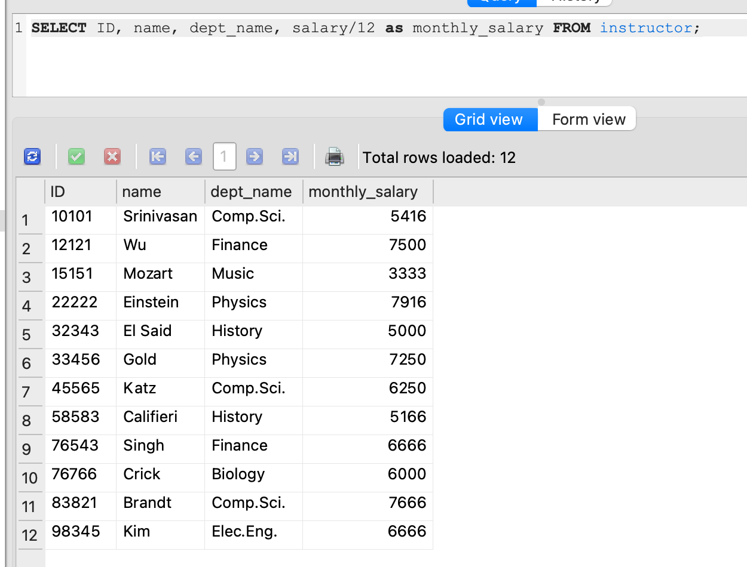

QUESTION 2: List all the instructor teaching in “Comp. Sci.” department and have annual salary more than 60000

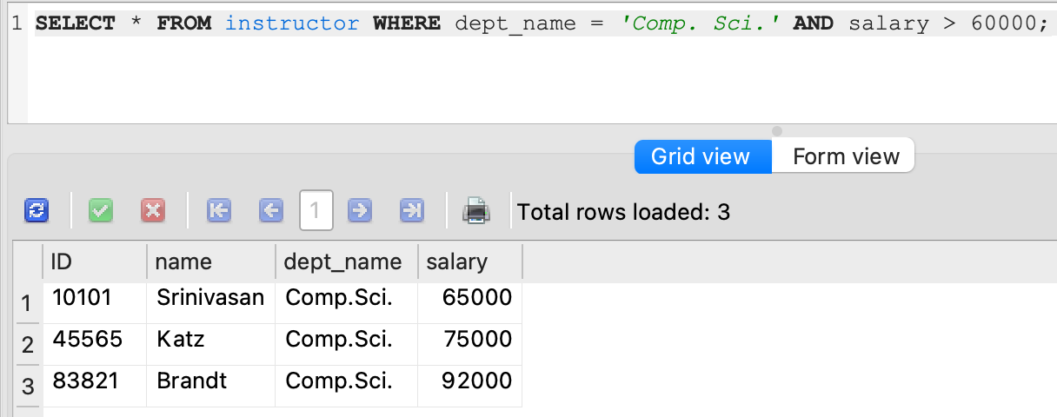

QUESTION 3: List all the names of all the instructors from Biology department

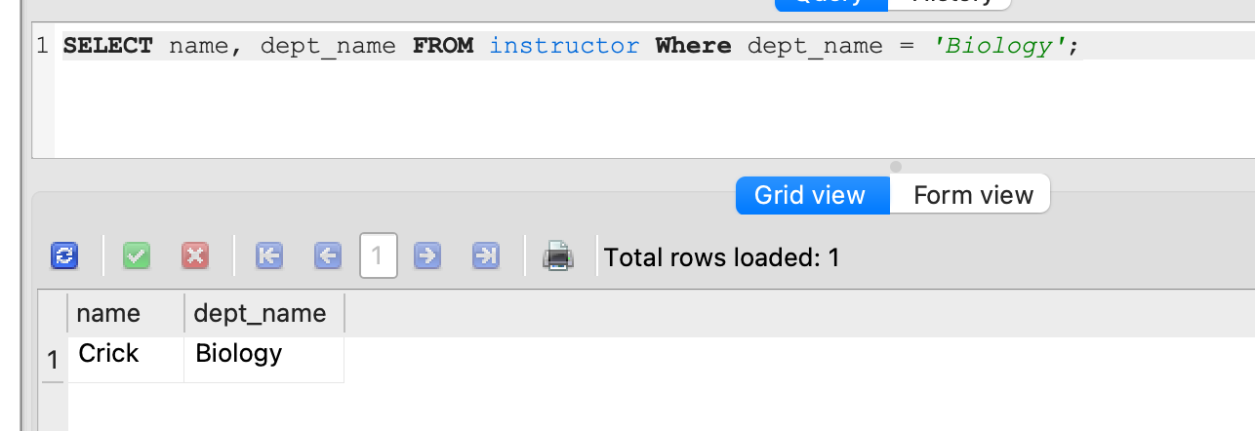

QUESTION 4: Find the titles of courses in the Comp. Sci. department that have 3 credits

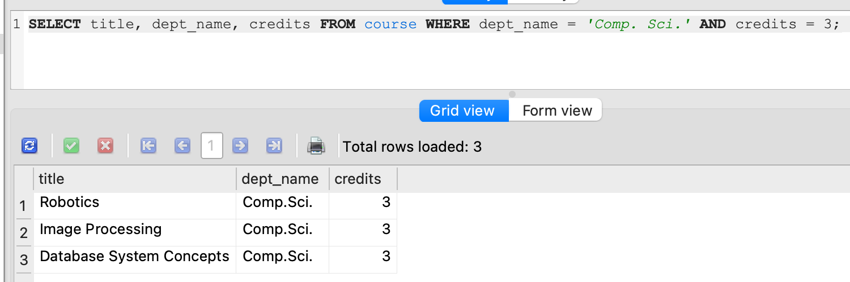

QUESTION 5: List the IDs of all students who were taught by an instructor named Einstein; make sure there are no duplicates in the result.

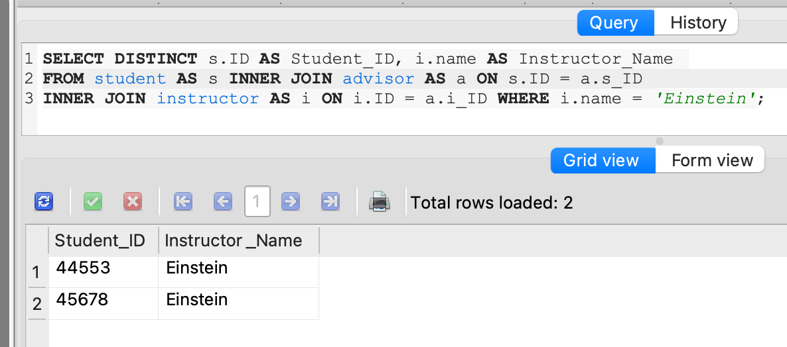

QUESTION 6: For the student with ID 12345 (or any other value), show all course_id and title of all courses registered for by the student.

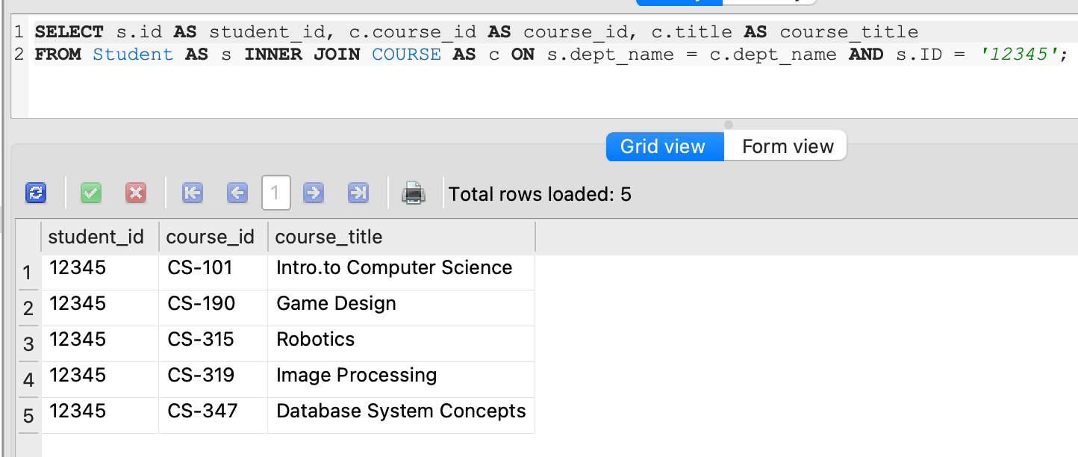

QUESTION 7: Find the highest salary of any instructor

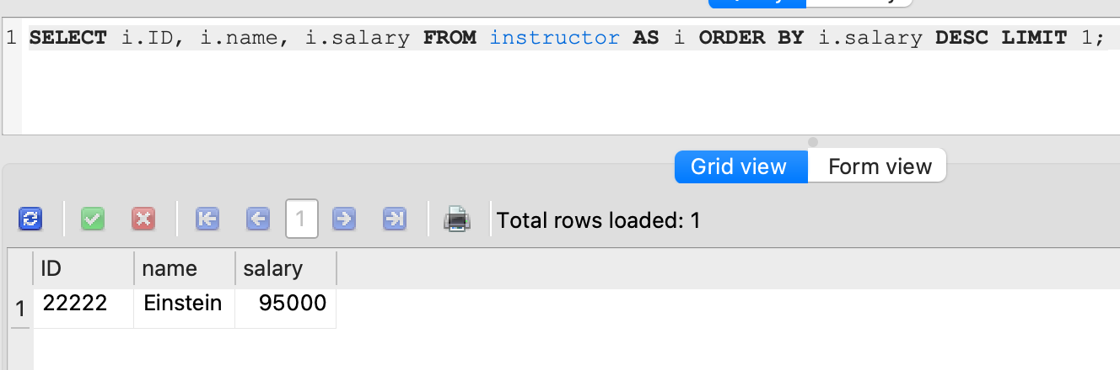

QUESTION 8: Find all instructors earning the highest salary (there may be more than one with the same salary).

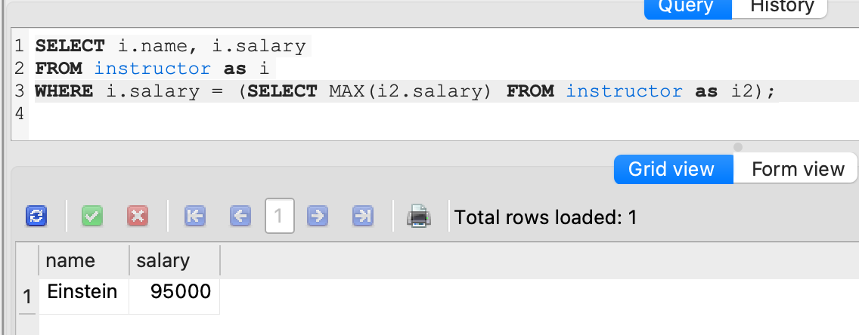

QUESTION 9: List all instructor with their IDs, name, department, annual salary teaching in any departments which have budget >= 100000

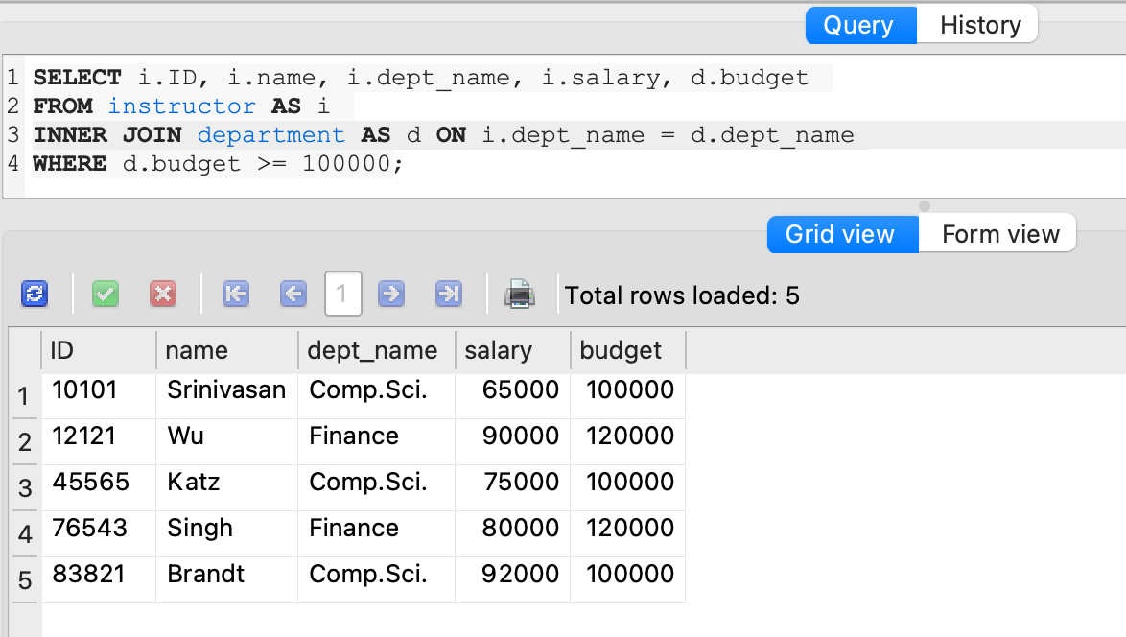

QUESTION 10: Find the names of all students who have taken any Comp. Sci. course ever (there should be no duplicate names)

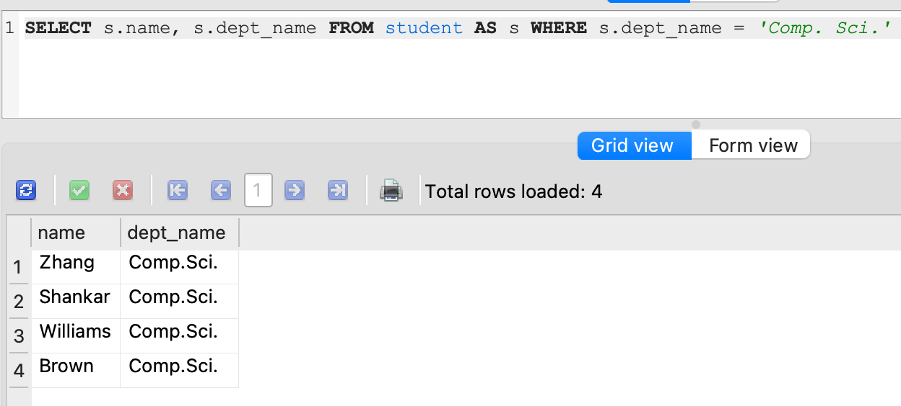

QUESTION 11: Find the enrollment of each section that was offered in Fall 2017.

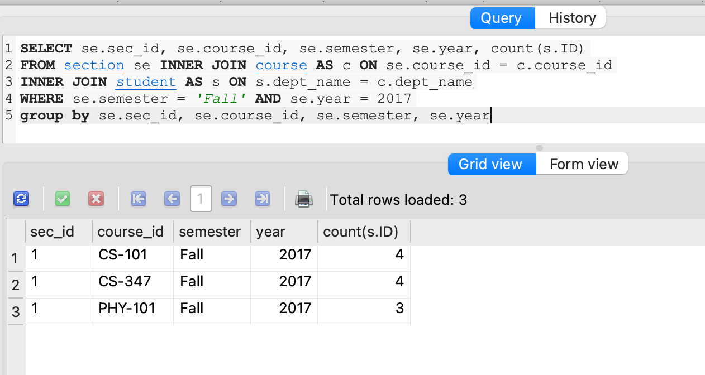

QUESTION 12: Find the maximum enrollment, across all sections, in Fall 2017.

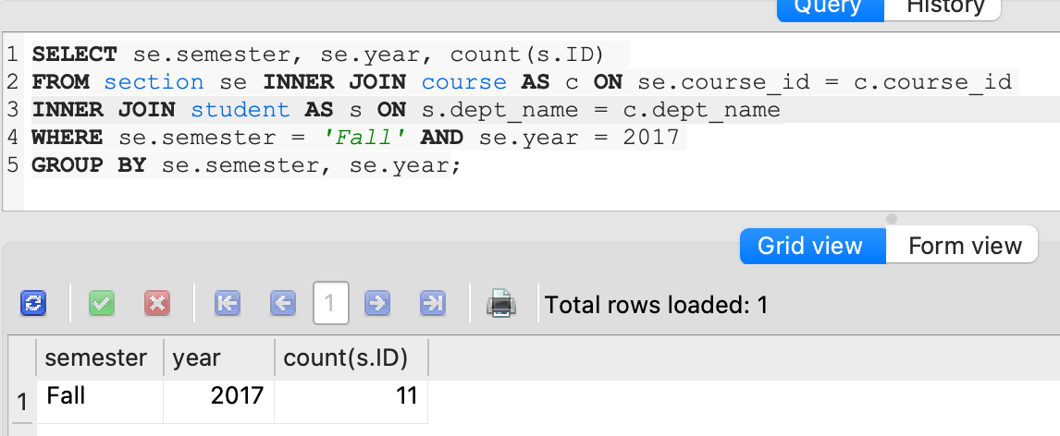

QUESTION 13: Find all courses whose identifier starts with the string "CS-1"

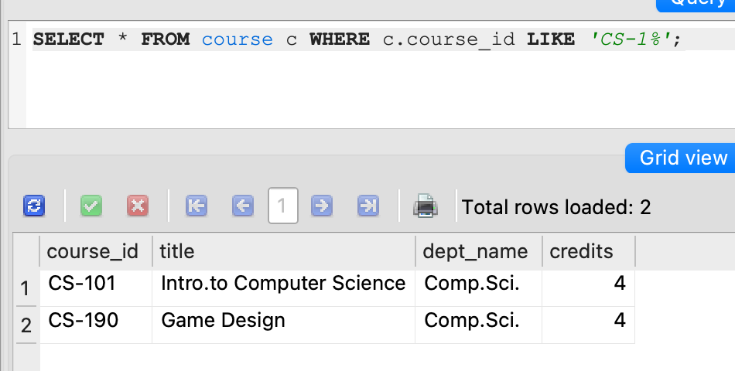

# ASSIGNMENT 2 - ANSWERS

QUESTION 1 Provide a query showing Customers (just their full names, customer ID and country) who are not in the US.

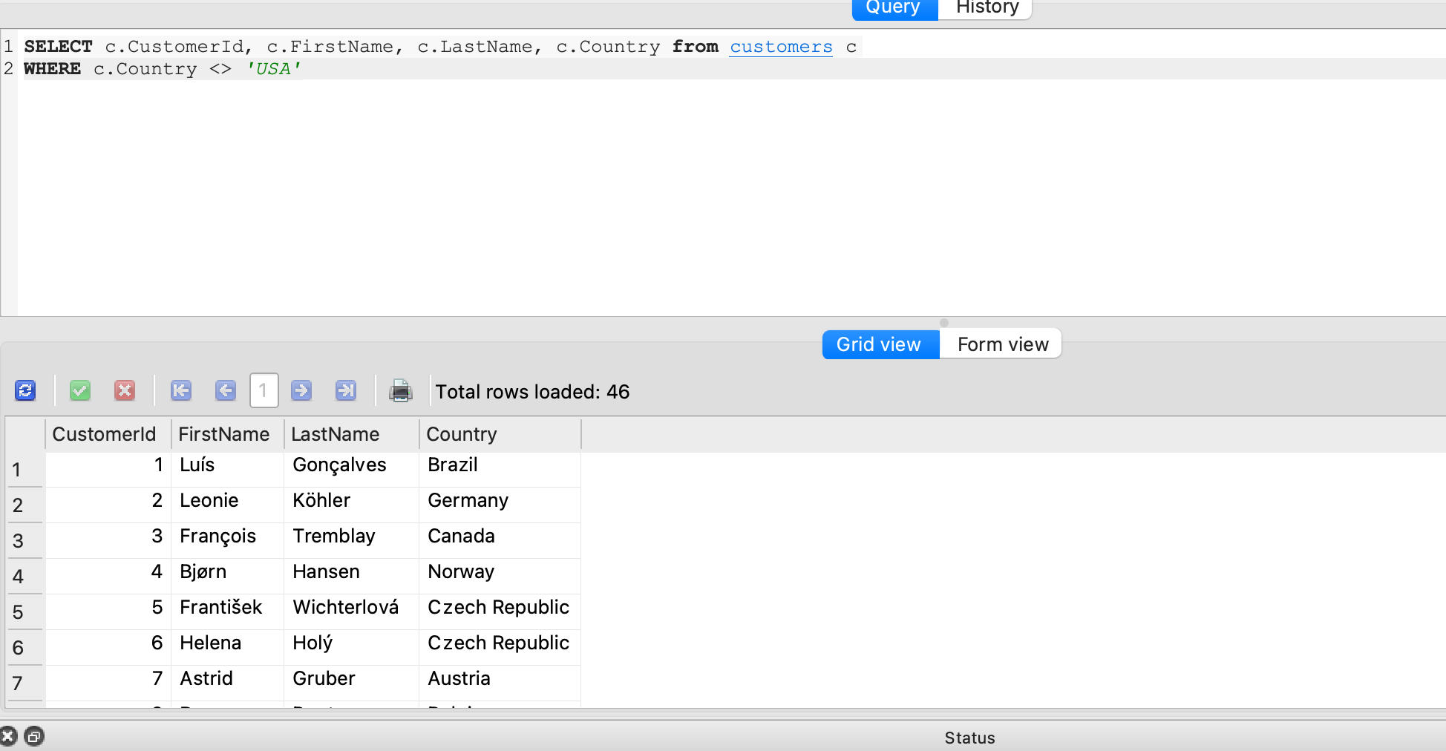

QUESTION 2 Provide a query only showing the Customers from Brazil

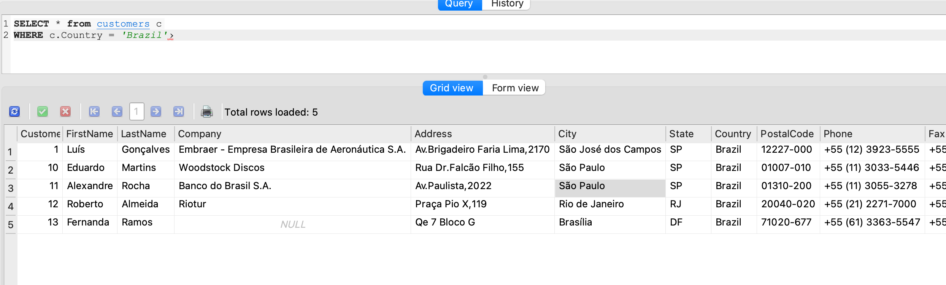

QUESTION 3 Provide a query showing the Invoices of customers who are from Brazil.

The result should show the customer's full name, Invoice ID, Date of the invoice and billing country

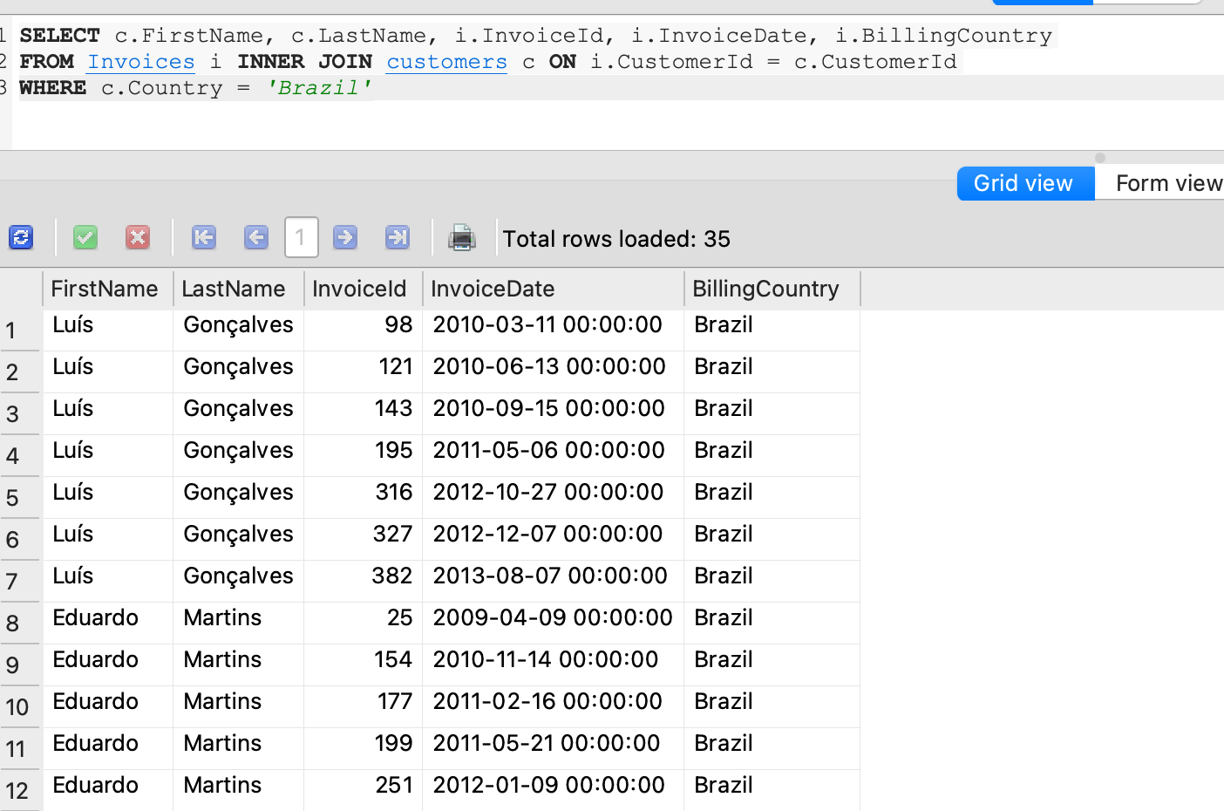

QUESTION 4. Provide a query showing only the Employees who are Sales Agents

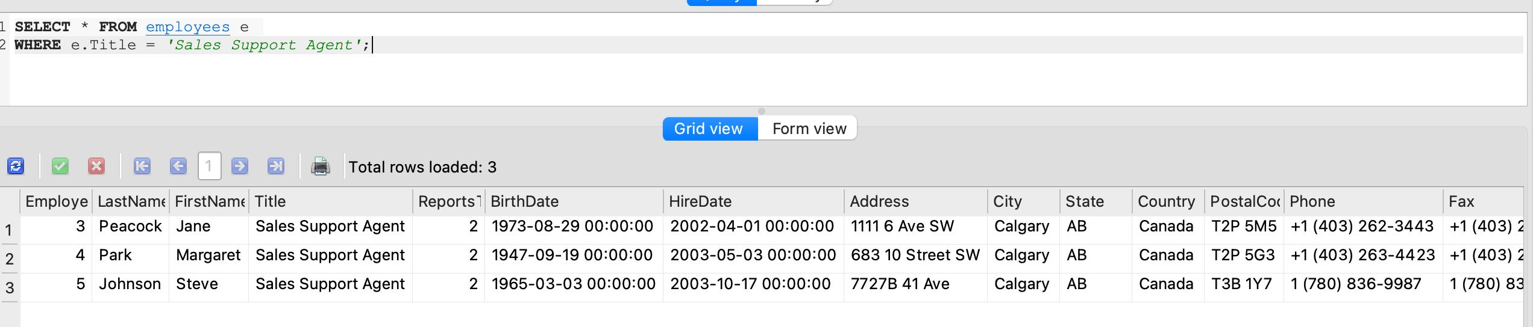

QUESTION 5. Provide a query showing a unique list of billing countries from the Invoice table

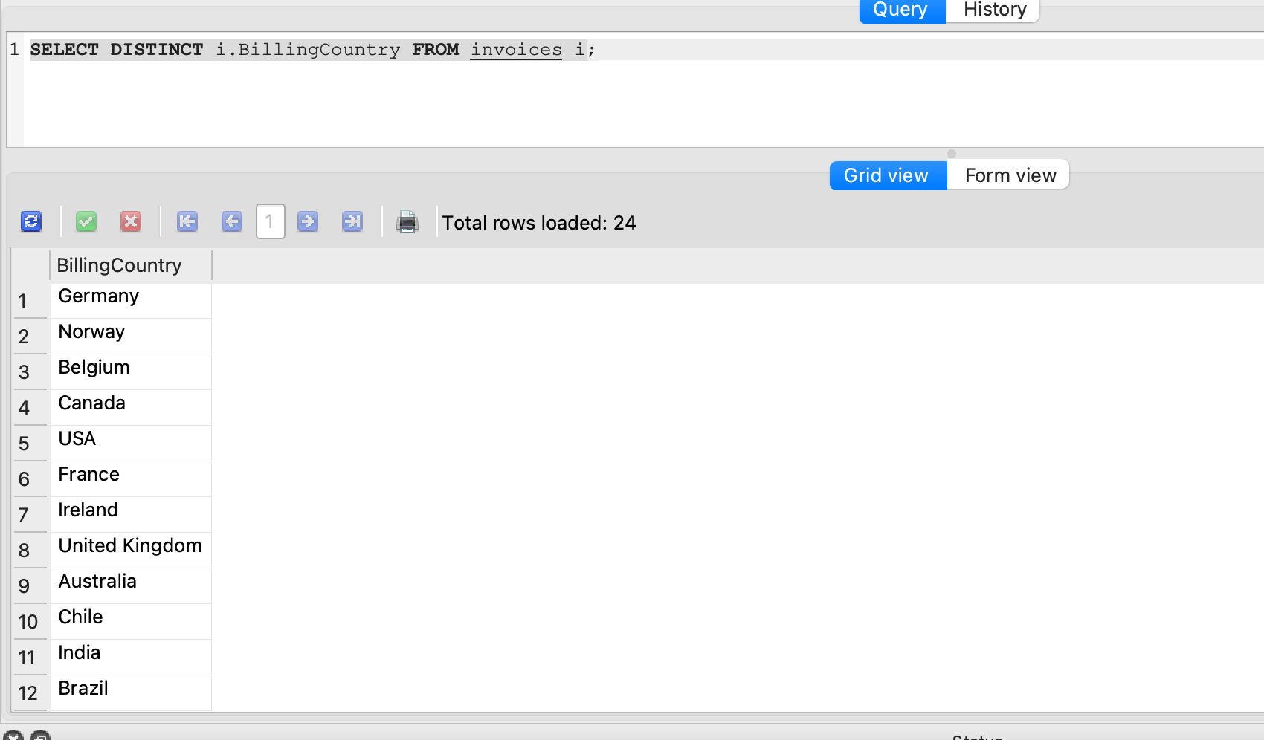

QUESTION 6. Provide a query that shows the invoices associated with each sales agent. The resultant table should include the Sales Agent's full name

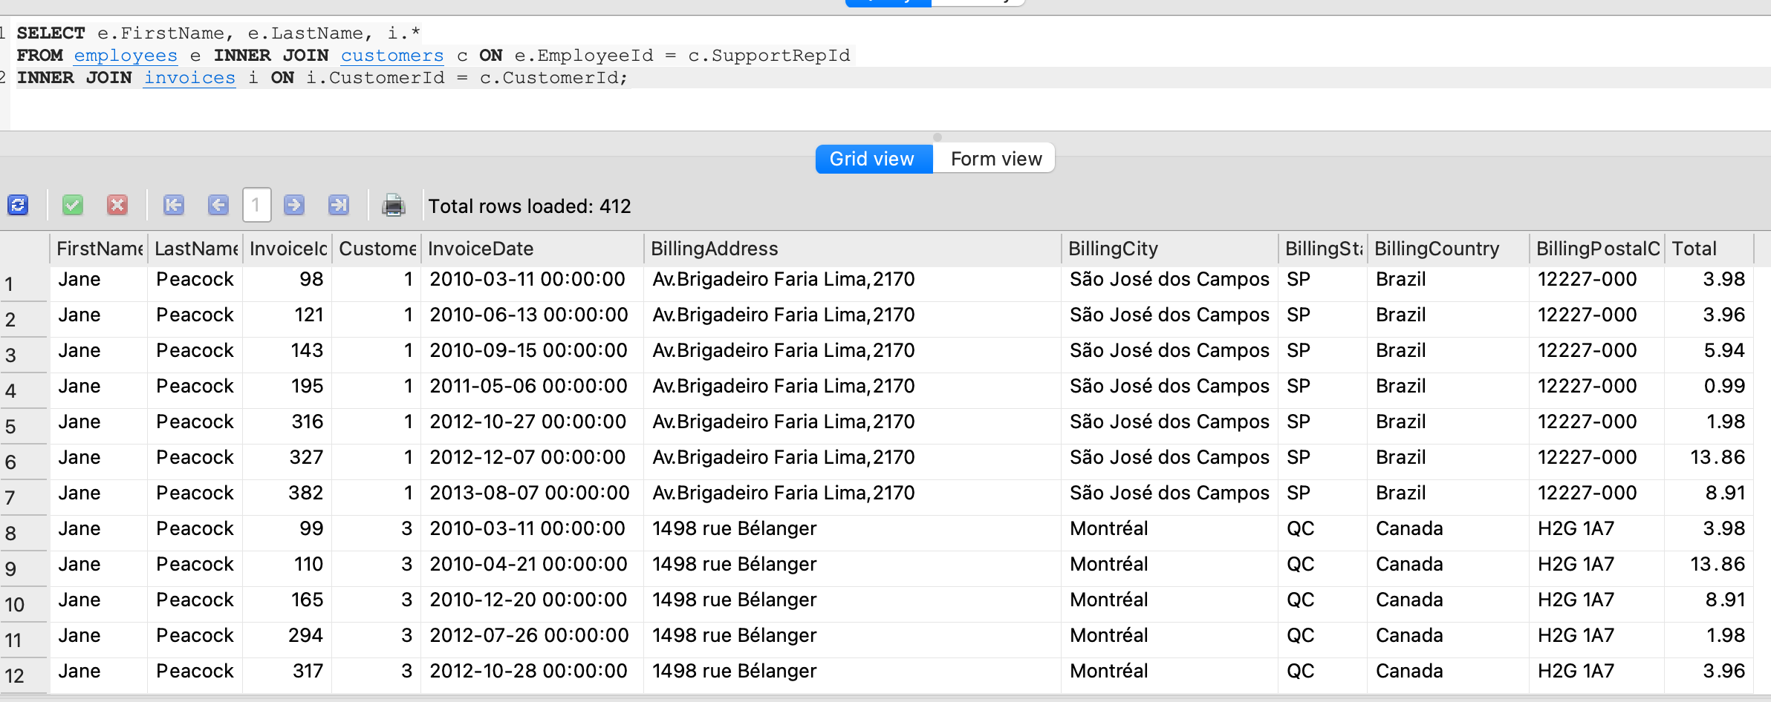

QUESTION 7. Provide a query that shows the Invoice Total, Customer name, Country and Sale Agent name for all invoices and customers

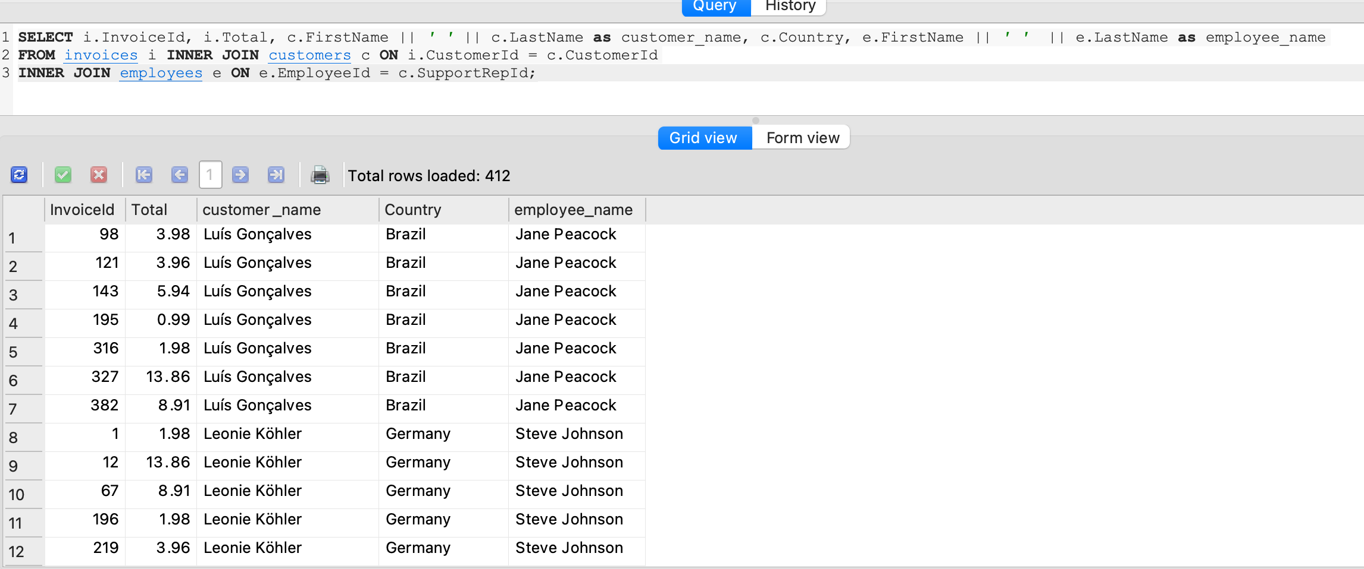

QUESTION 8. How many Invoices were there in 2009 and 2011? What are the respective total sales for each of those years?

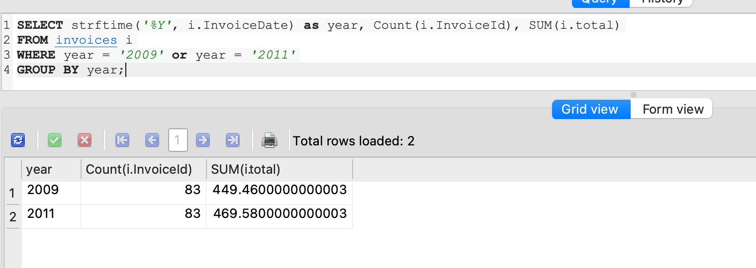

QUESTION 9. Looking at the InvoiceLine table, provide a query that COUNTs the number of line items for Invoice ID 37

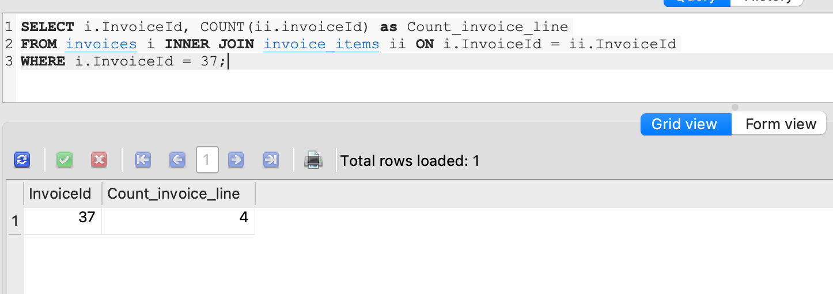

QUESTION 10. Looking at the InvoiceLine table, provide a query that COUNTs the number of line items for each Invoice.

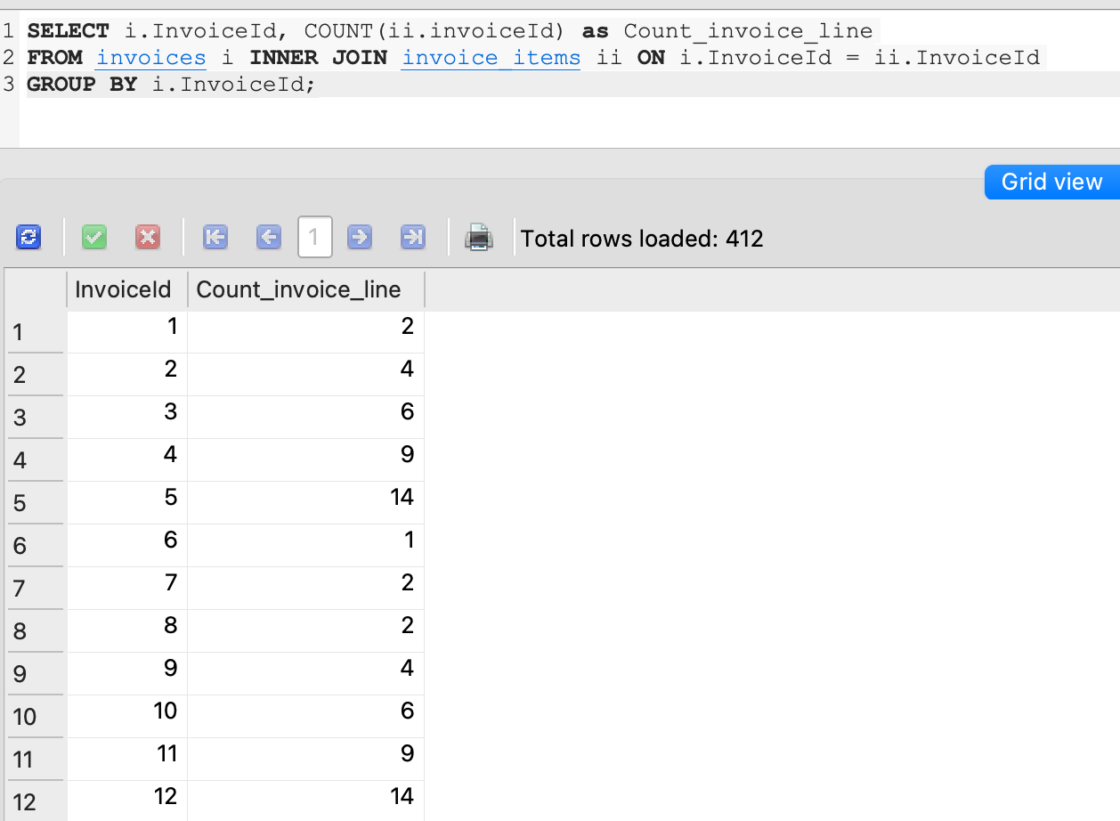

QUESTION 11. Provide a query that includes the track name with each invoice line item.

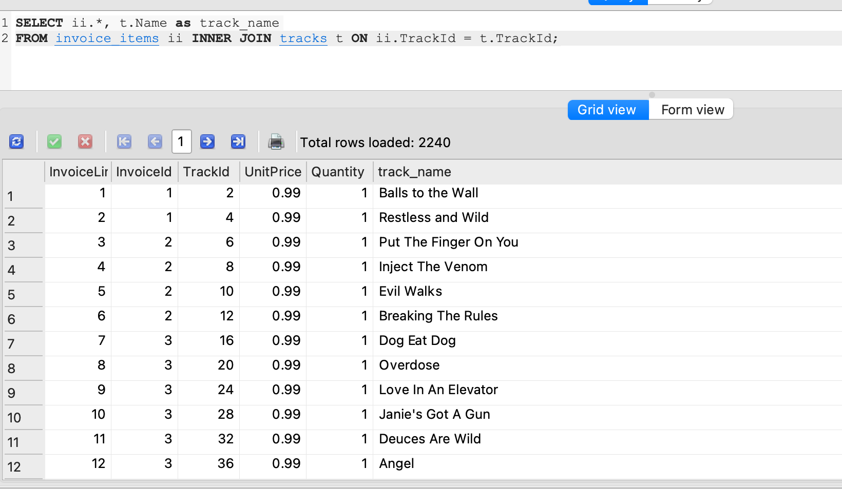

QUESTION 12. Provide a query that includes the purchased track name AND artist name with each invoice line item.

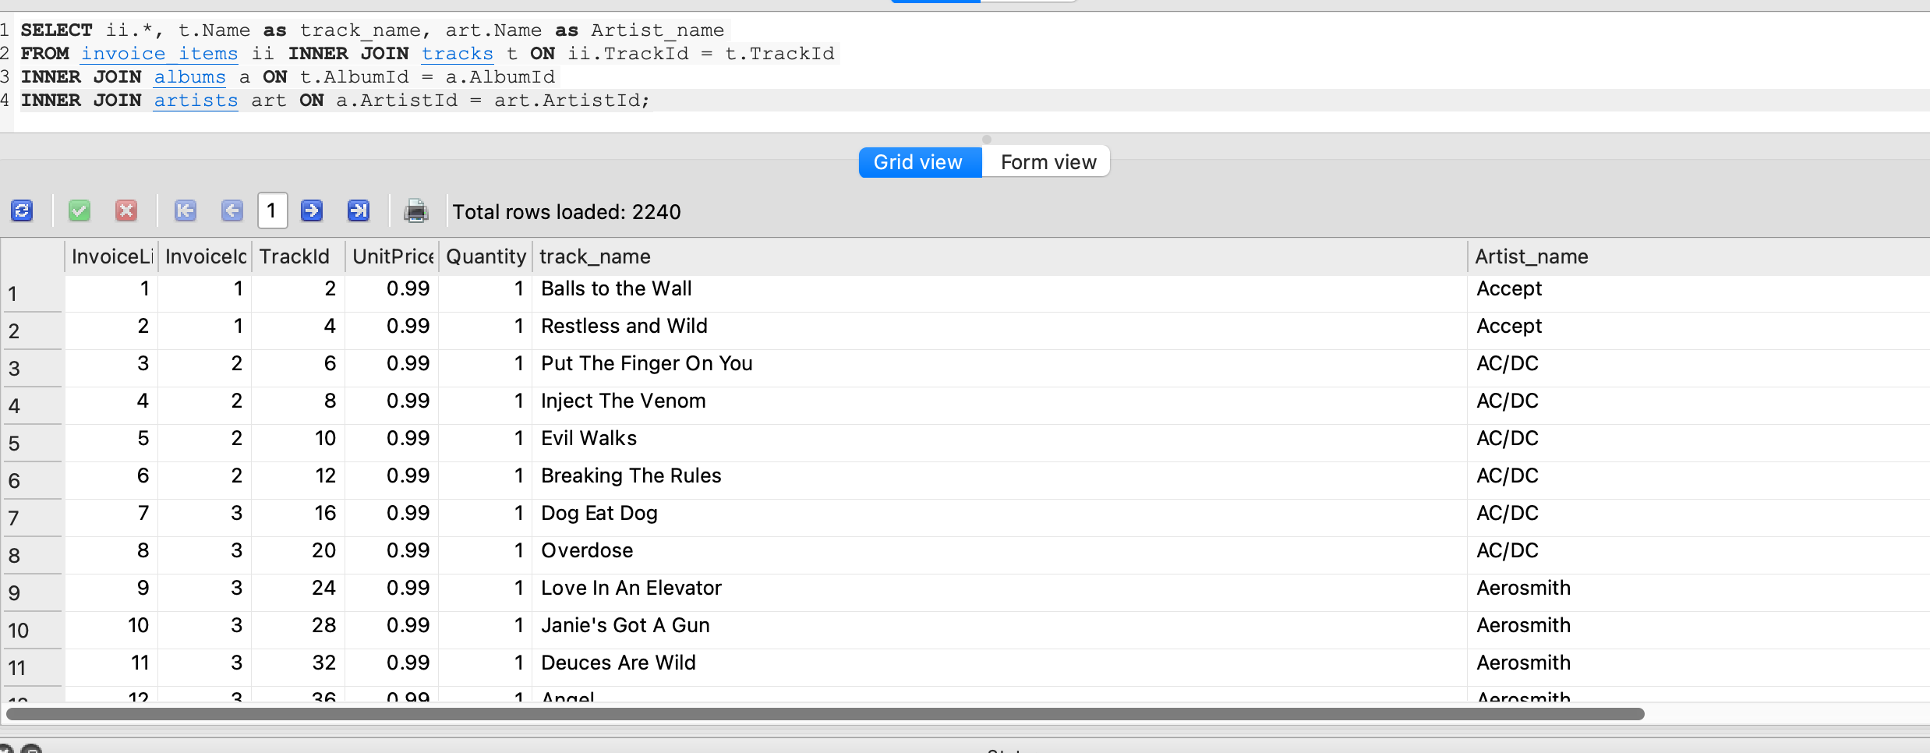

QUESTION 13. Provide a query that shows the number of invoices per country.

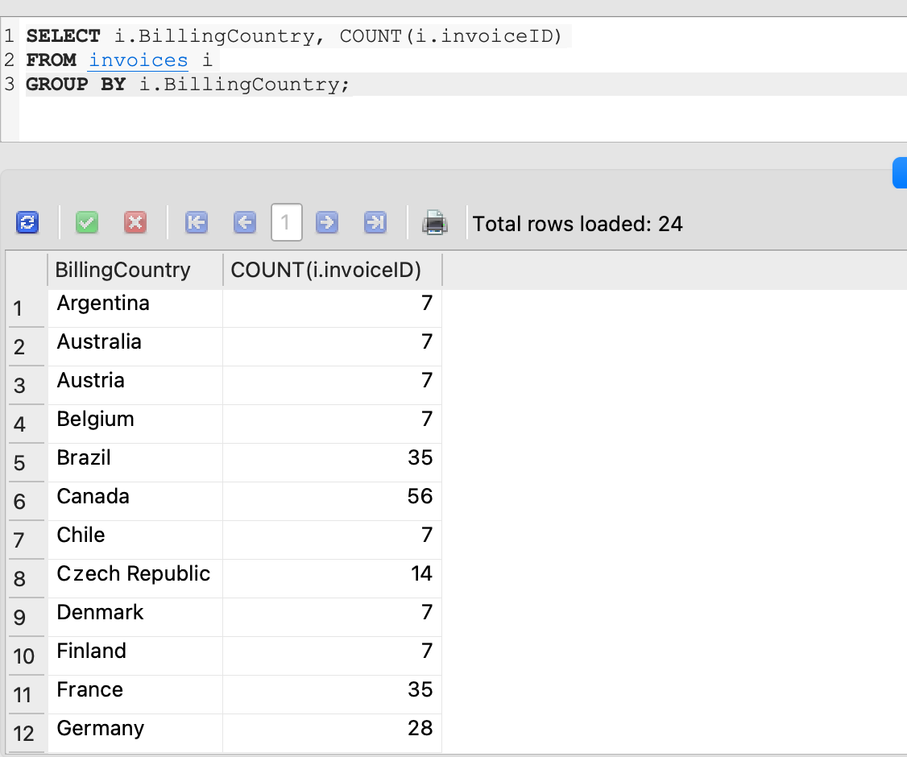

QUESTION 14. Provide a query that shows the total number of tracks in each playlist. The Playlist name should be included on the resultant table.

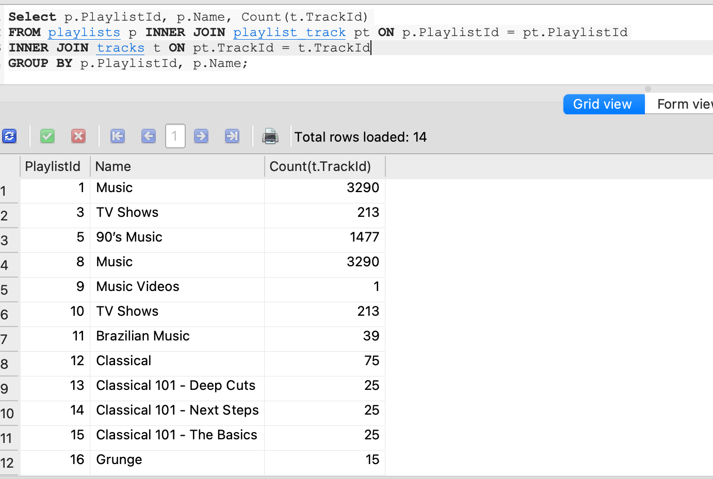

QUESTION 15. Provide a query that shows all the Tracks, but displays no IDs. The resultant table should include the Album name, Media type and Genre.

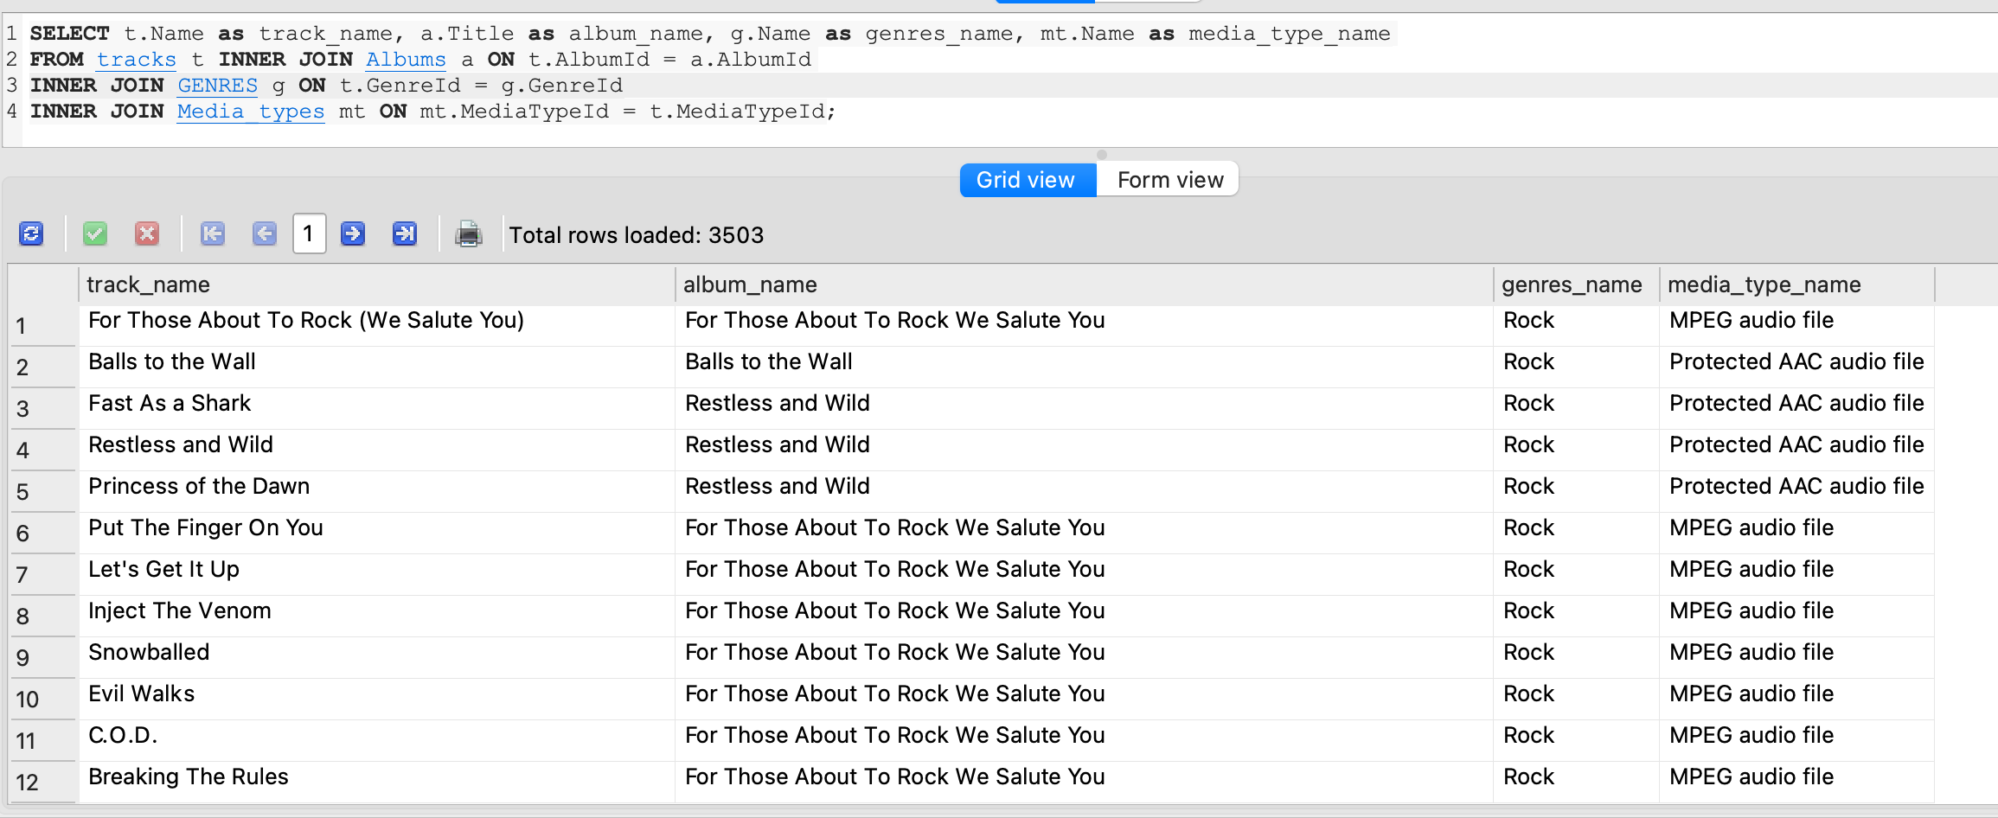

QUESTION 16. Provide a query that shows all Invoices but includes the number of invoice line items.

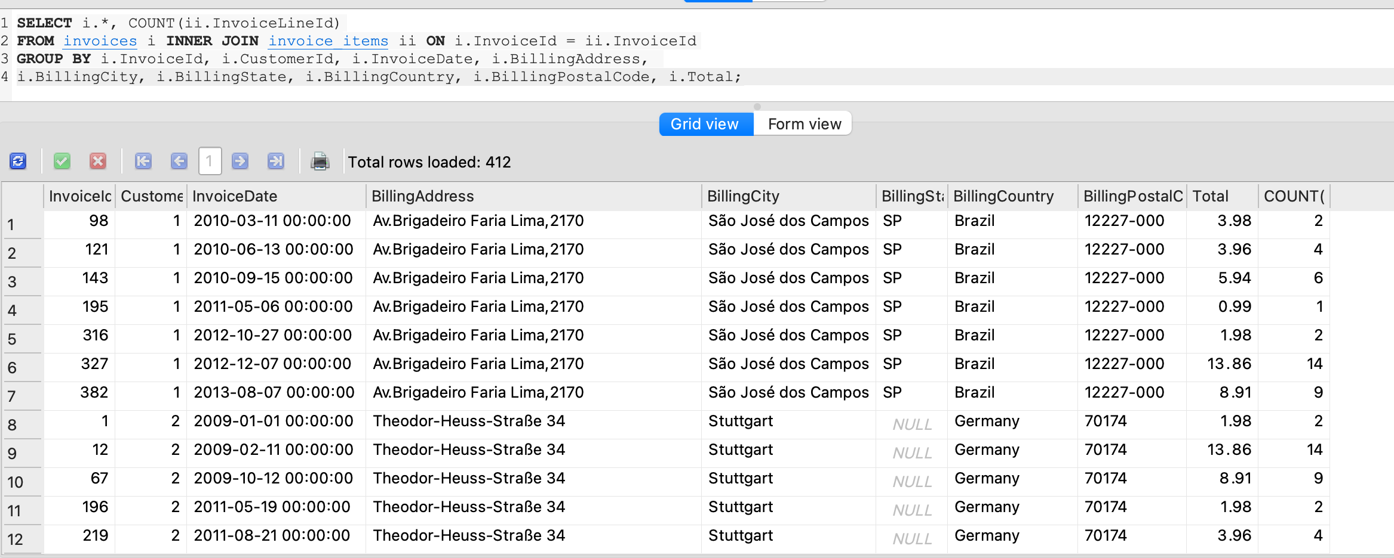

QUESTION 17. Provide a query that shows total sales made by each sales agent.

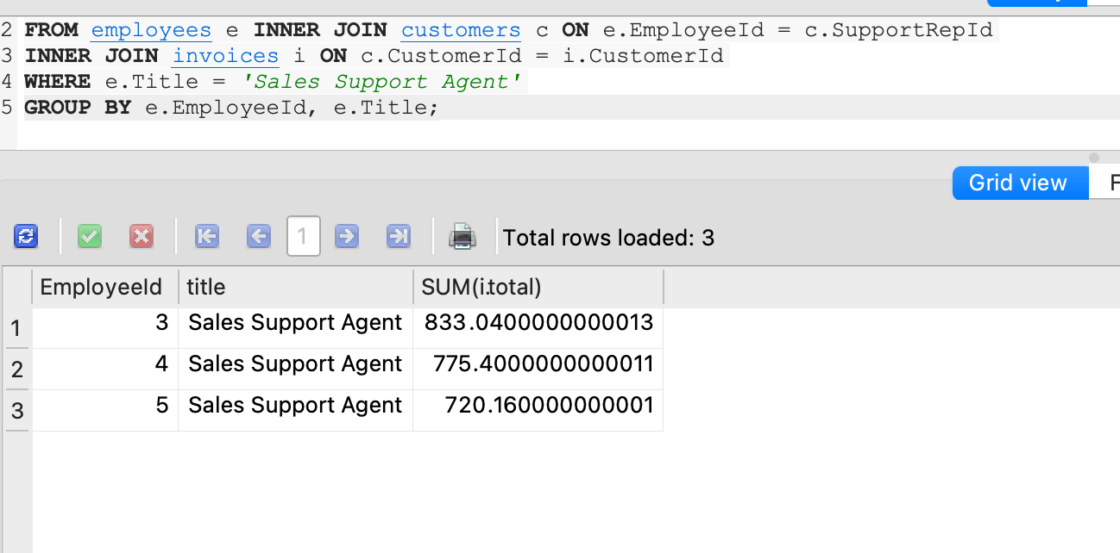

QUESTION 18. Provide a query that shows the total sales per country. Which country's customers spent the most?

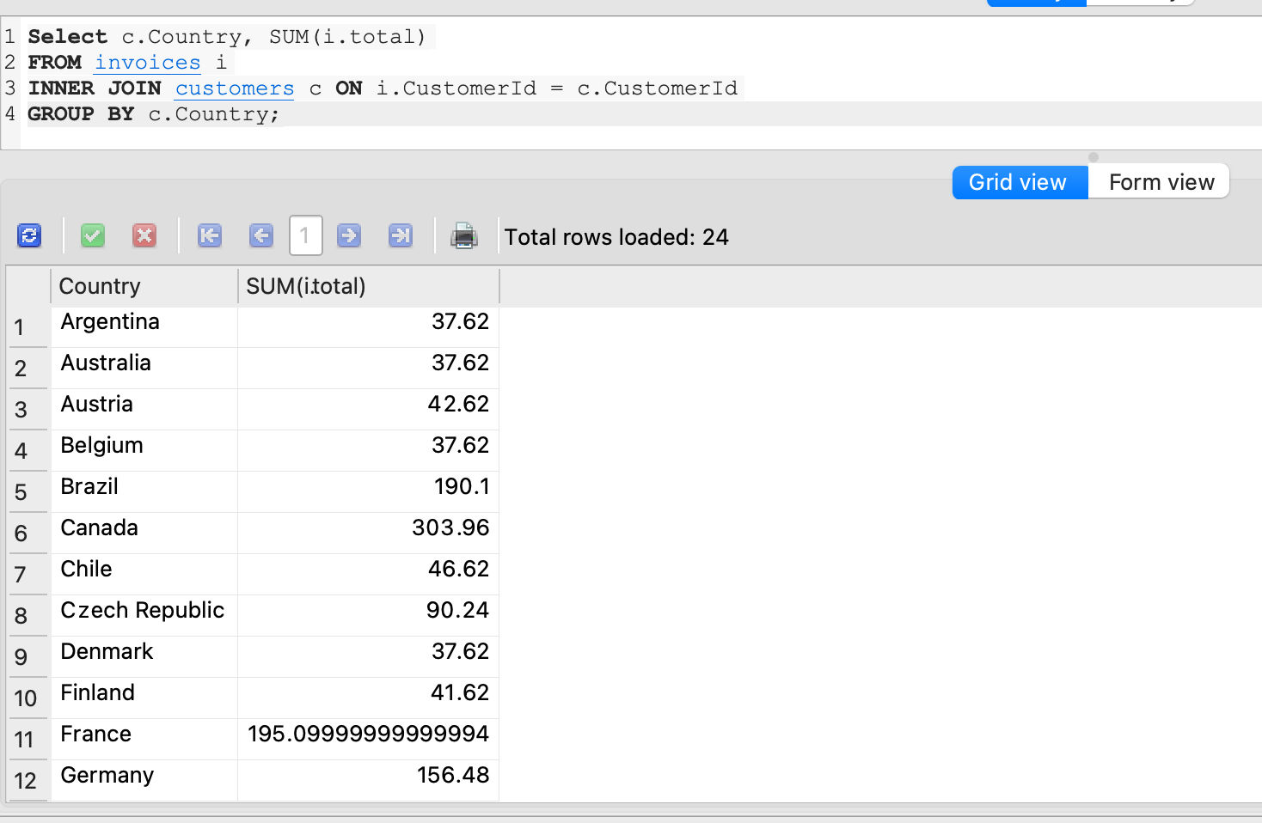

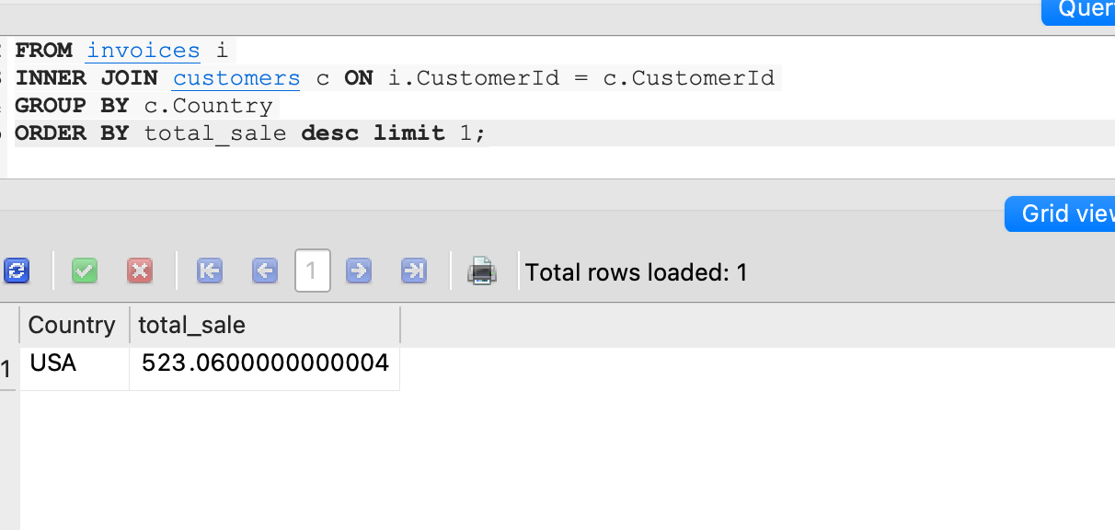

QUESTION 19. Which sales agent made the most in sales in 2009?

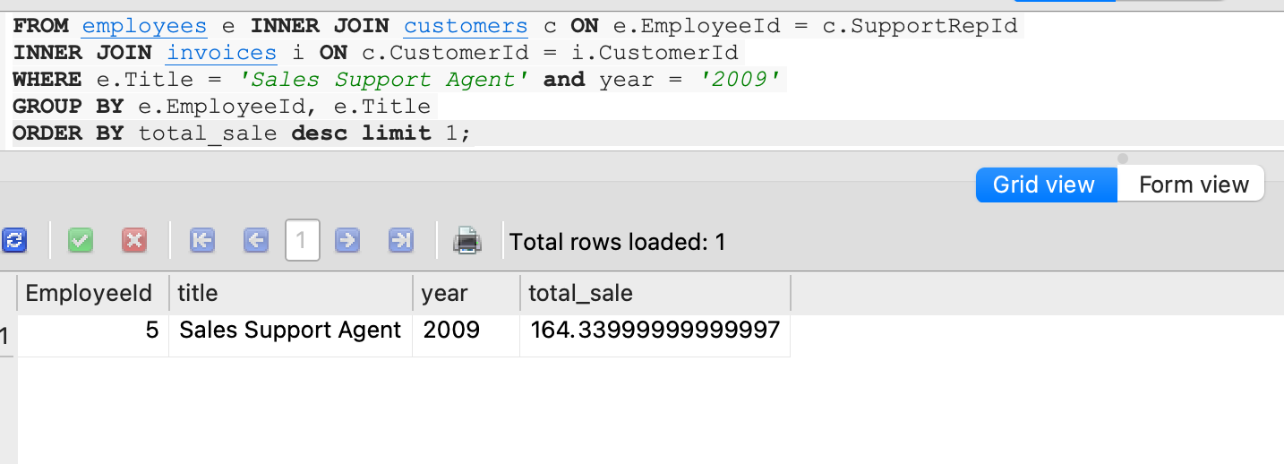

QUESTION 20. Which sales agent made the most in sales in 2010?

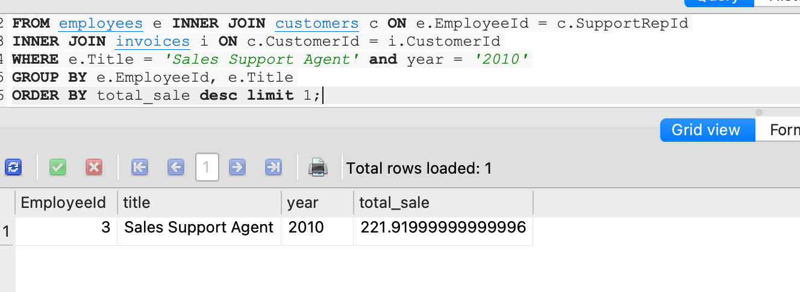

QUESTION 21. Which sales agent made the most in sales over all?

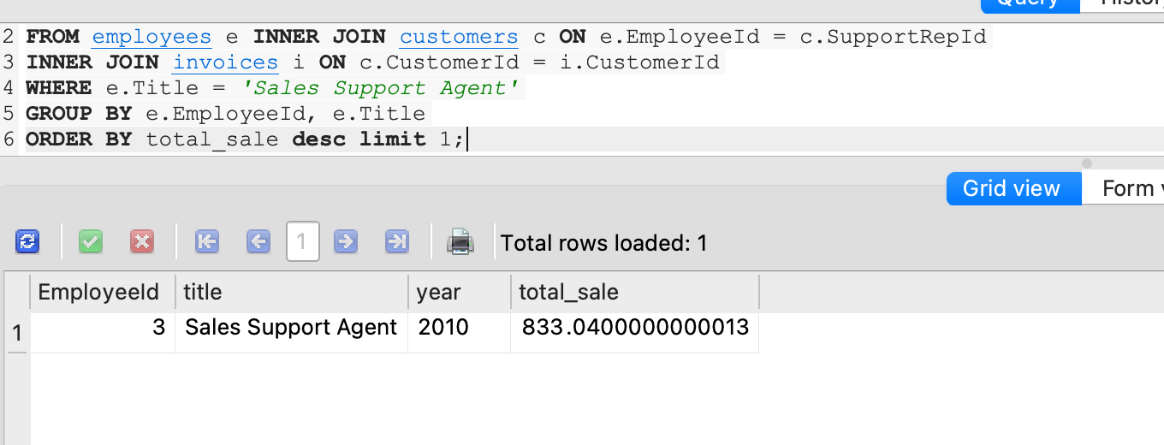

QUESTION 22. Provide a query that shows the top 5 most purchased tracks over all.

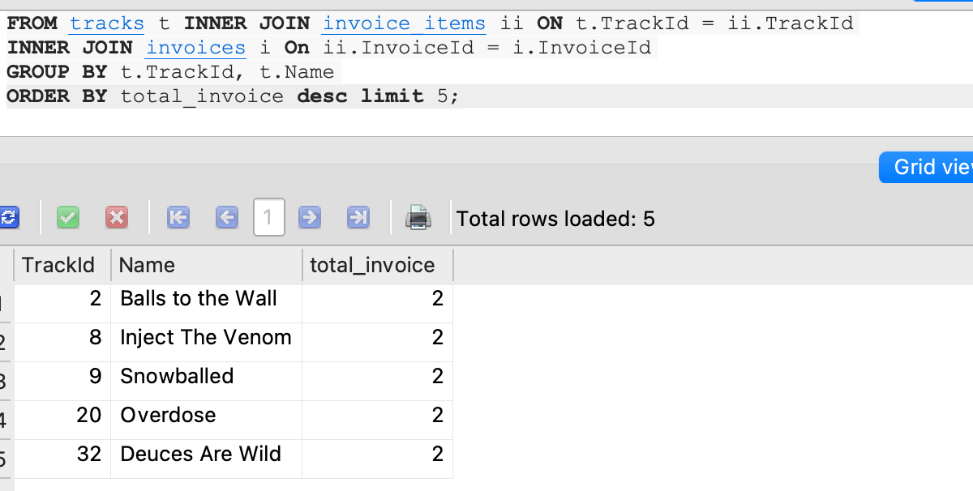

QUESTION 23. Provide a query that shows the top 3 best selling artists.

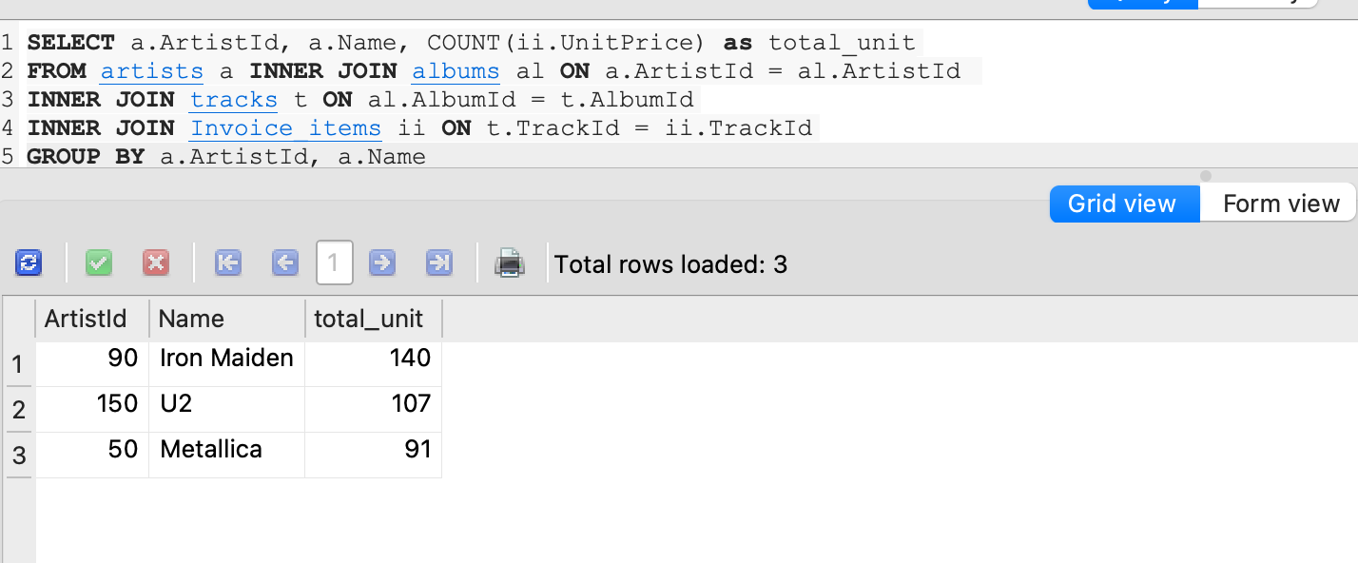

# ASSIGNMENT 3 - ANSWERS

QUESTION 1: In table employees, write a query to display the names (first_name, last_name) using alias name "First Name", "Last Name"

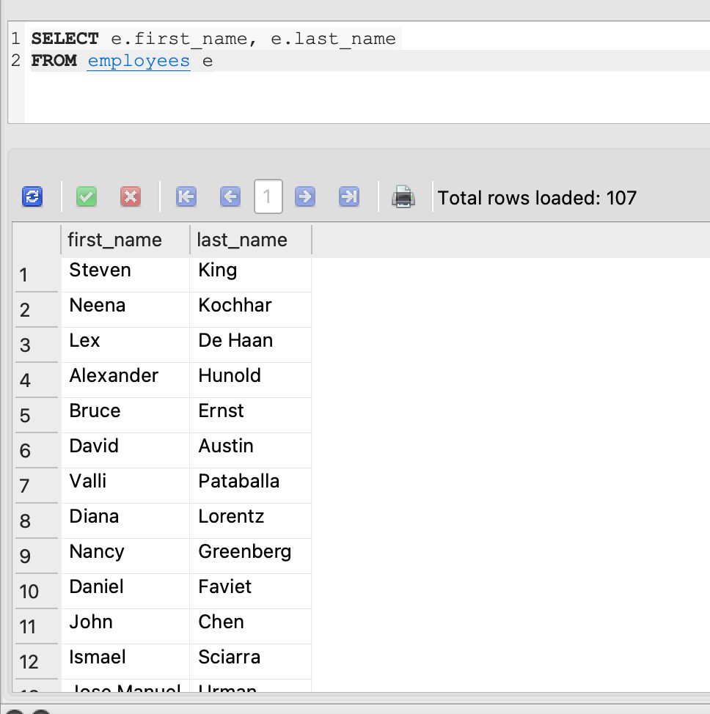

2. List all unique department ID from employee table.

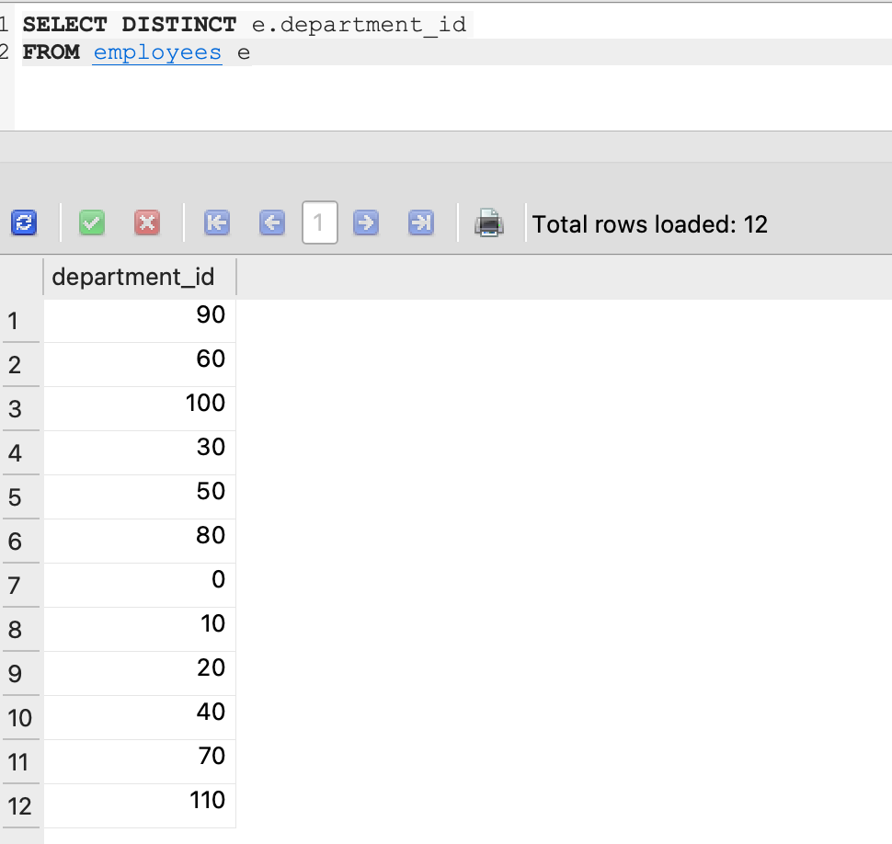

3. Find all employee details from the employee table order by first name, descending.

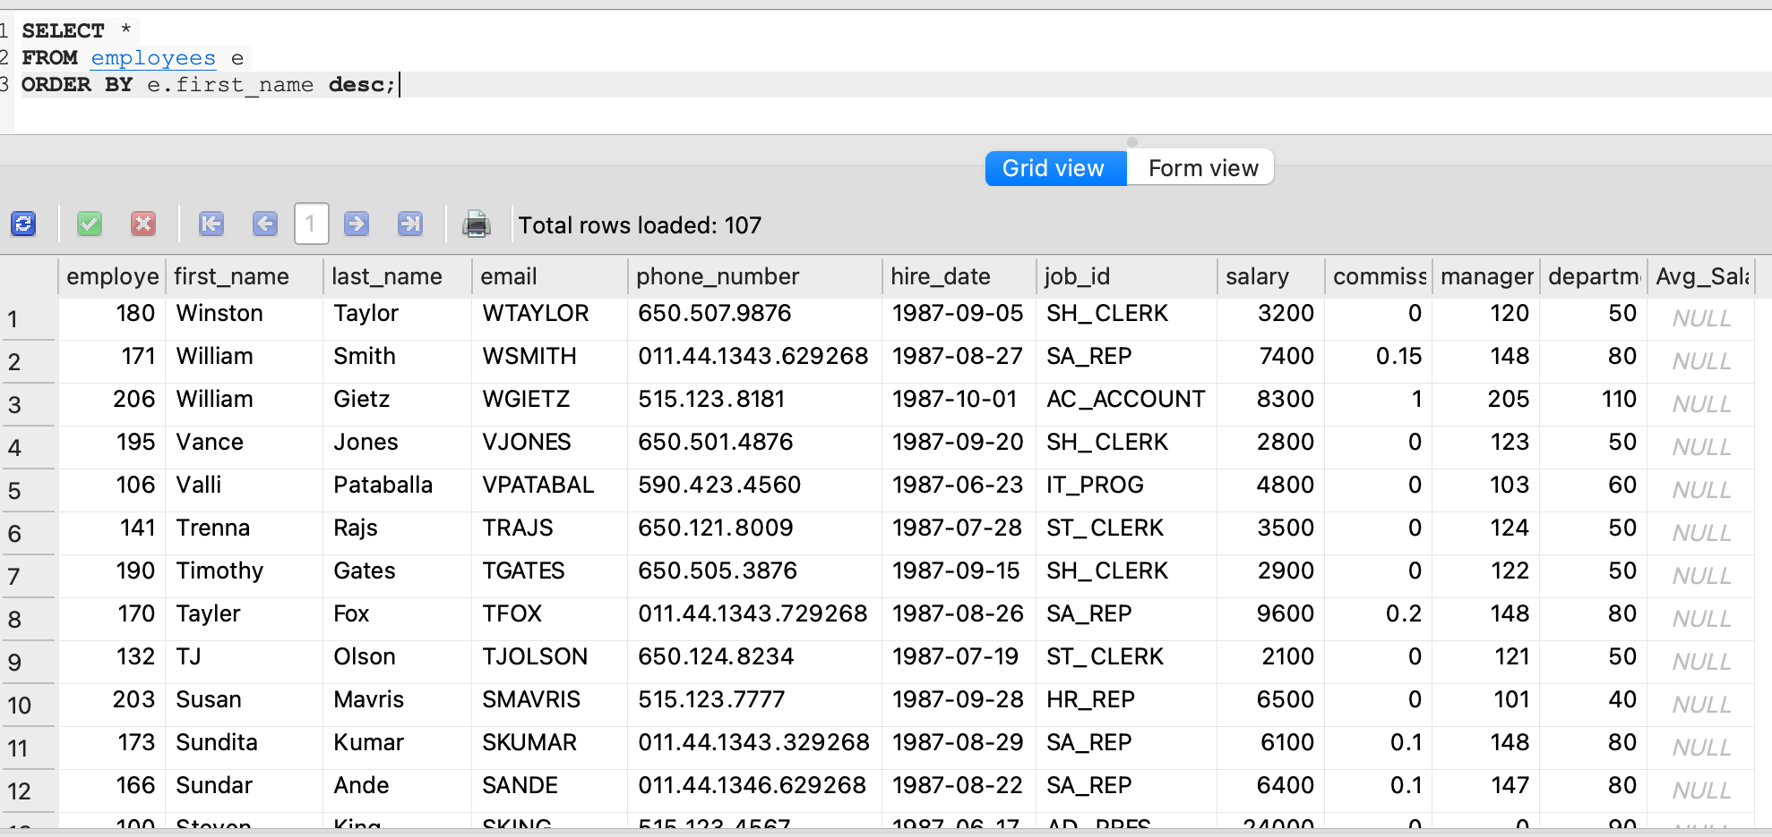

4. List all the names (first_name, last_name), salary, PF of all the employees (PF is calculated as 12% of salary)

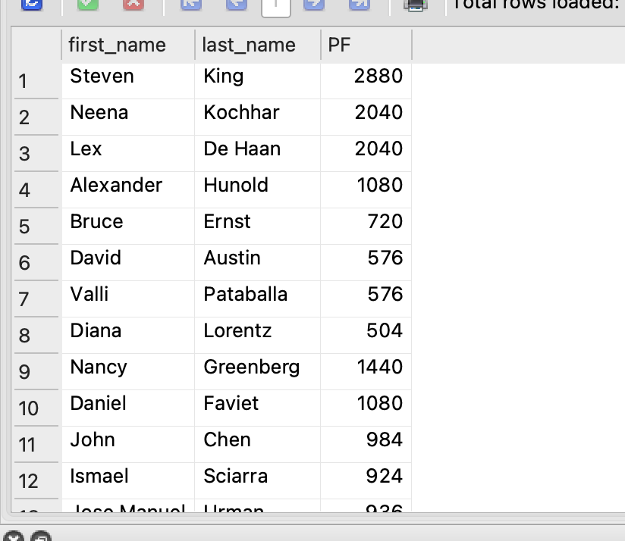

5. List all the employee ID, names (first_name, last_name), salary in ascending order of salary.

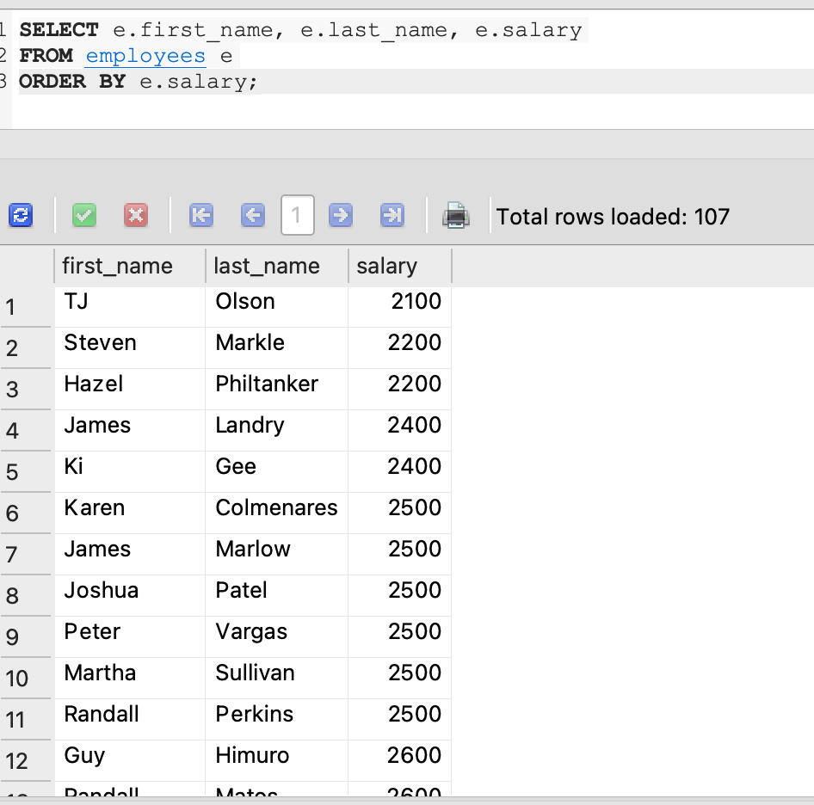

6. Find the total salaries payable to employees.

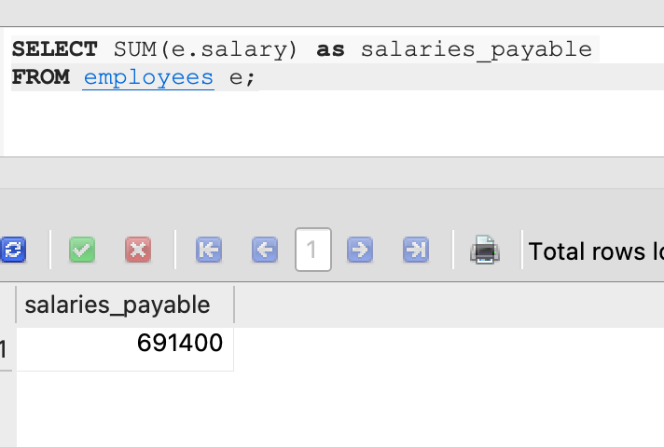

7. Find the maximum and minimum salary from employees table.

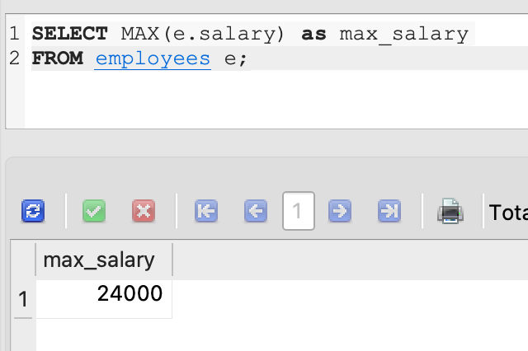

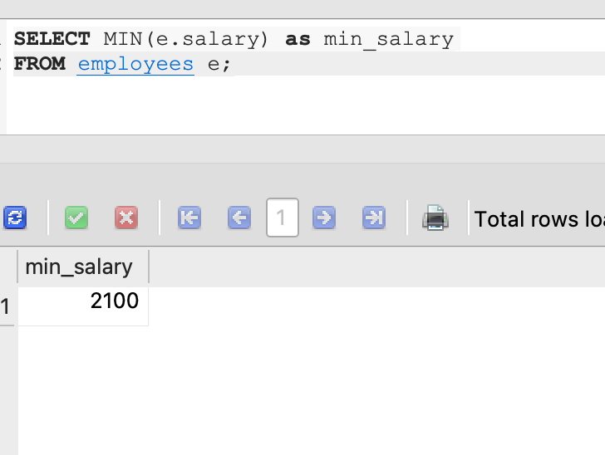

8. Find the average salary and number of employees in the employees table.

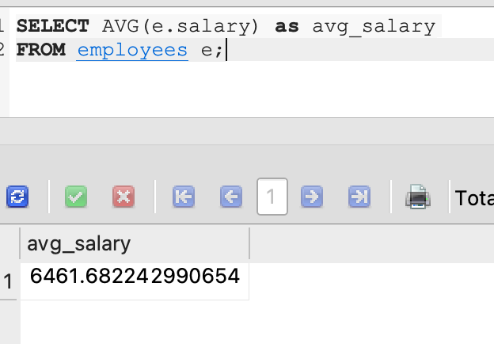

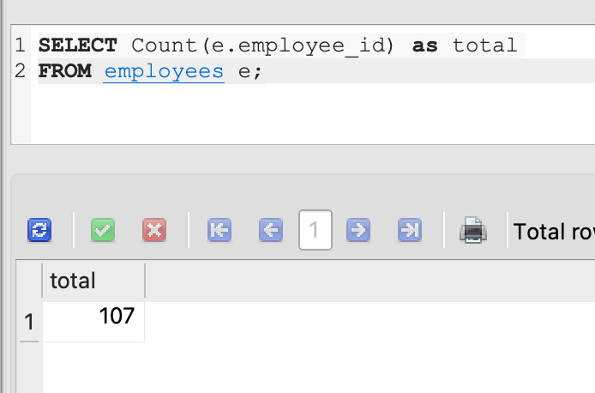

9. List all the number of employees working with the company.

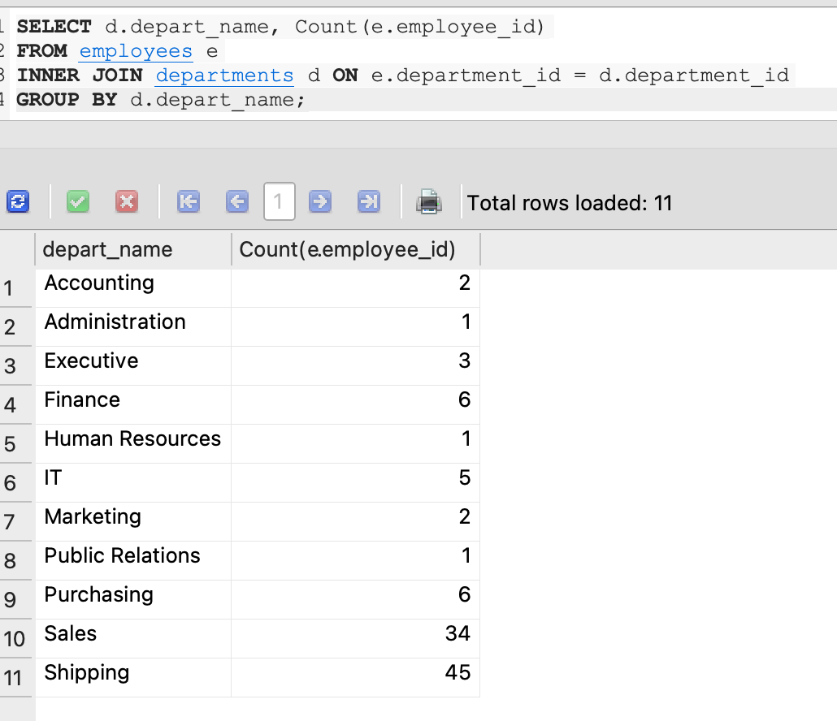

10. List all the number of jobs available in the employees table.

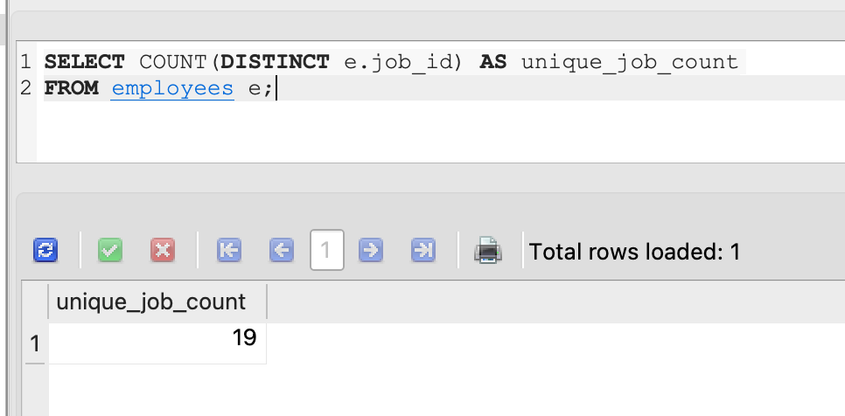

11. List all first name from employees table in upper case.

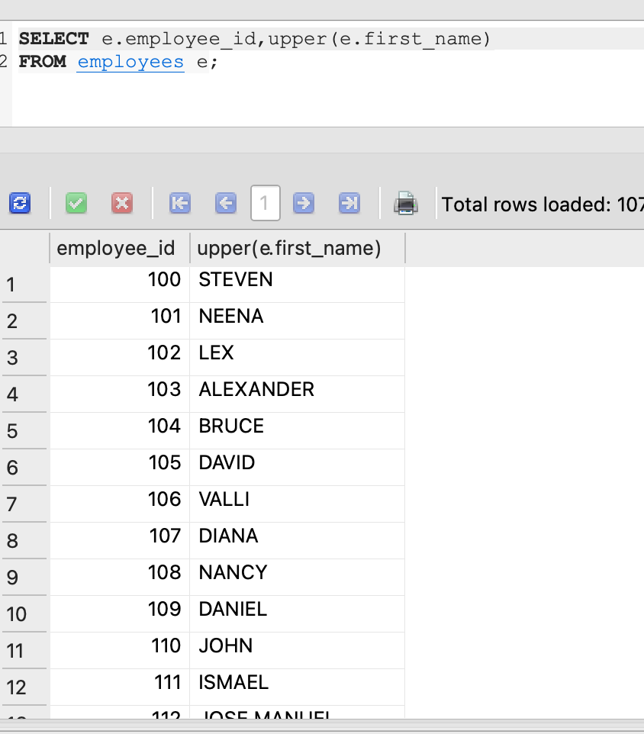

12. Find the first 3 characters of last name from employees table.

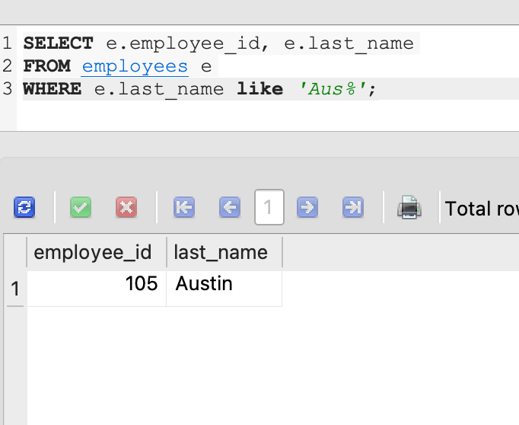

13. List the first 12 records from employees table

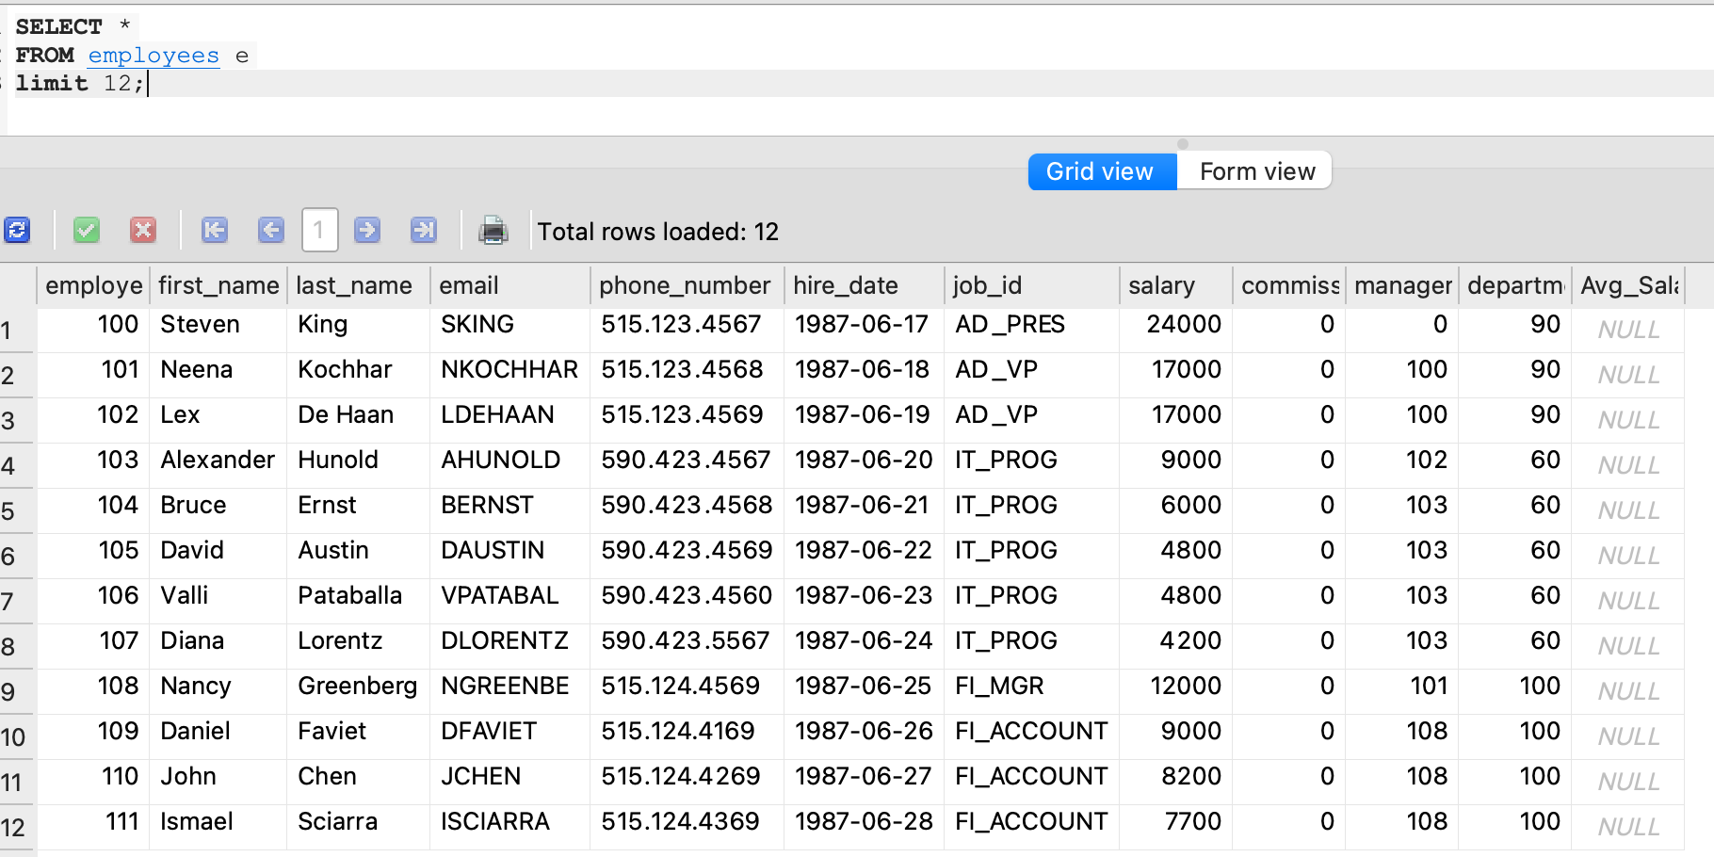

14. Display the names (first_name, last_name) and salary for all employees whose salary is not in the range $10,000 through $15,000.

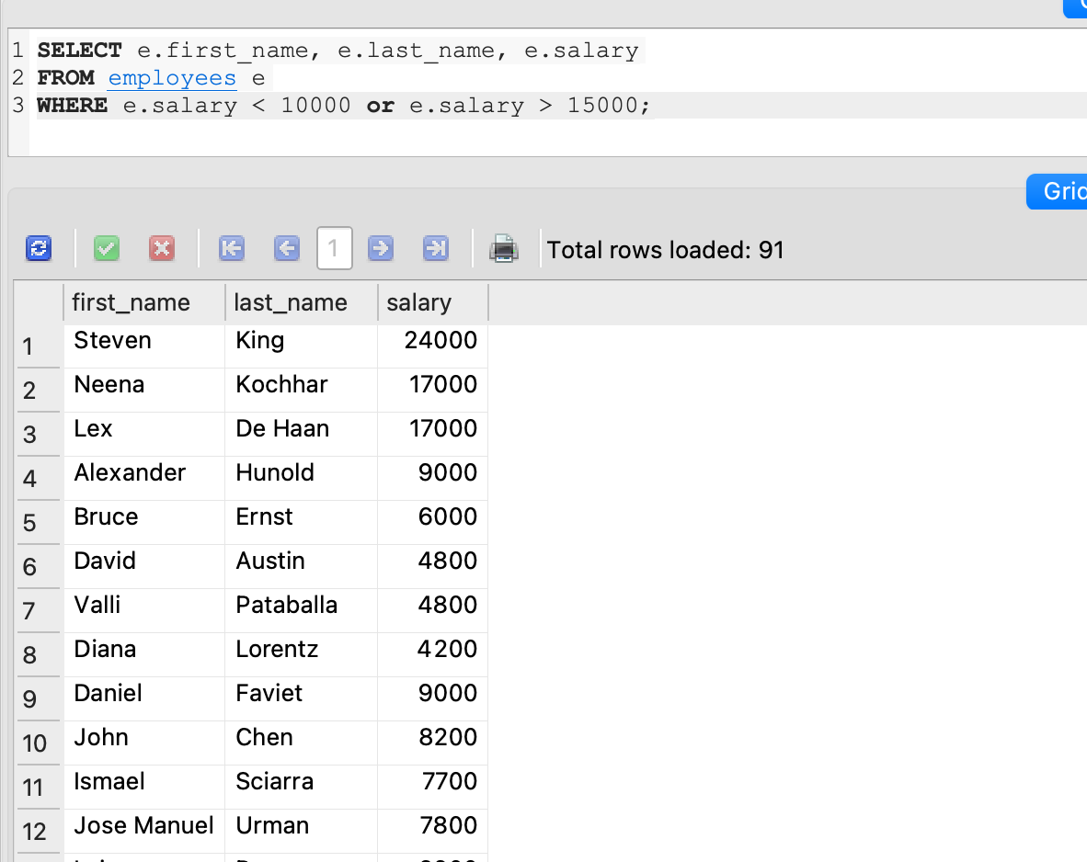

15. List the names (first_name, last_name) and department ID of all employees in departments 30 or 100 in ascending alphabetical order by department ID.

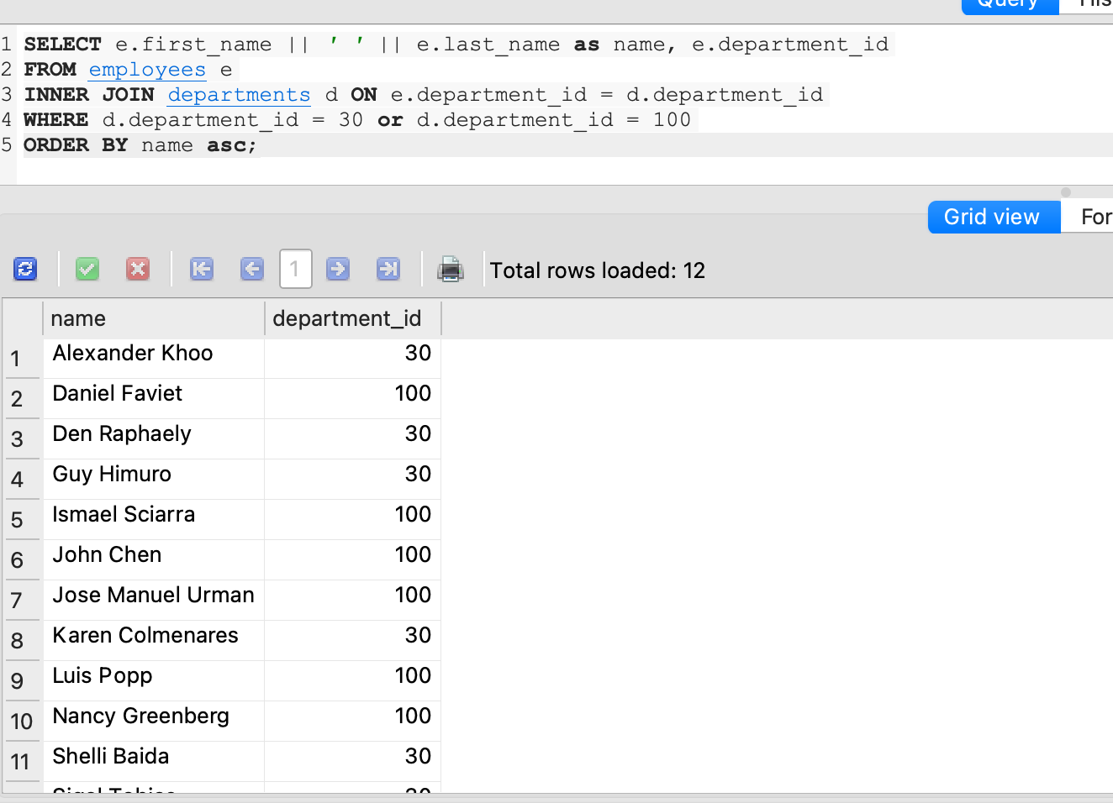

16. Display the names (first_name, last_name) and salary for all employees whose salary is not in the range $10,000 through $15,000 and are in department 30 or 100.

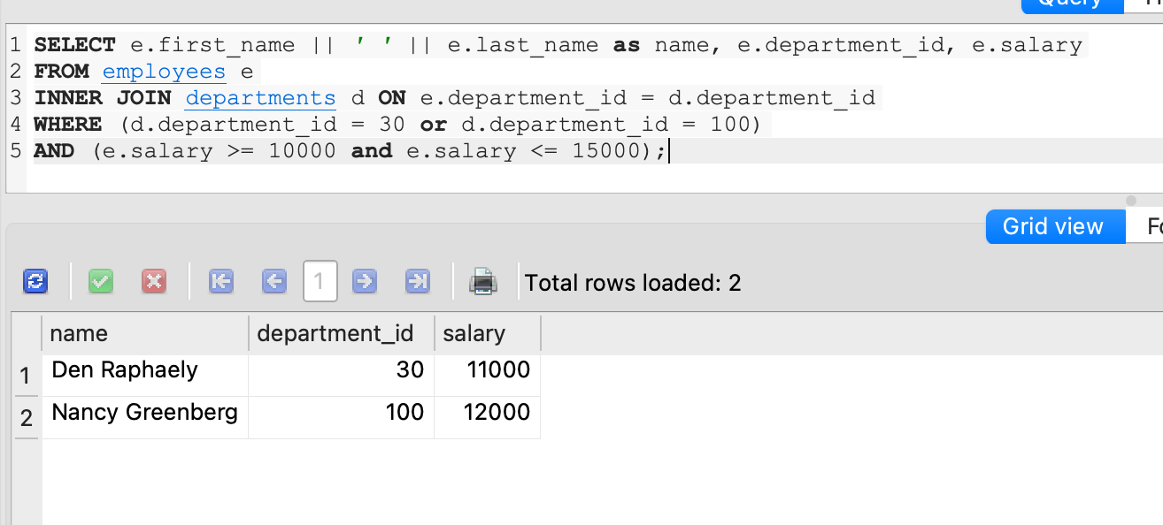

17. Find the minimum salary from employees table.

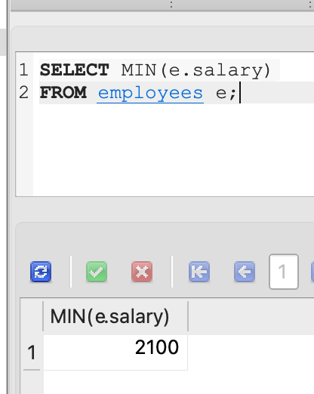

18. Find the maximum salary of an employee working as a Programmer.

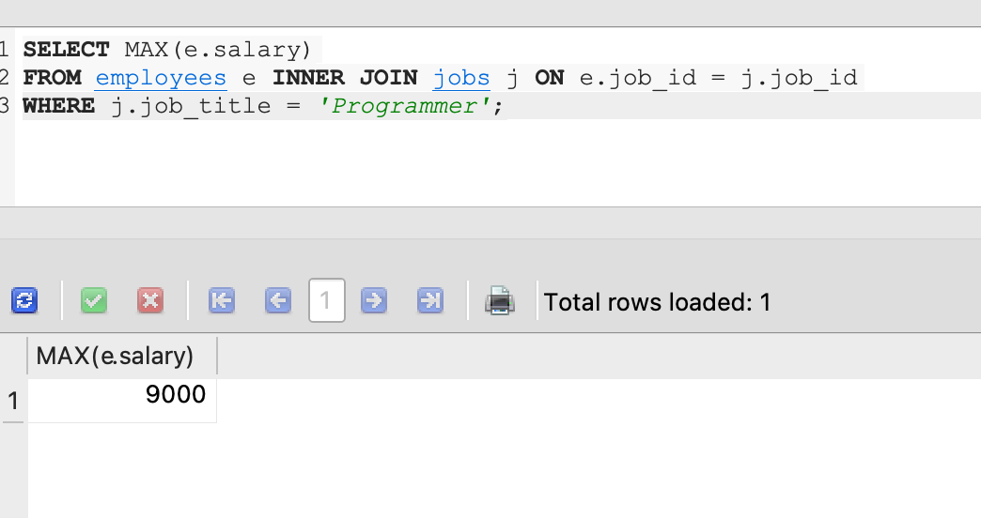

19. List all the employees with the same job.

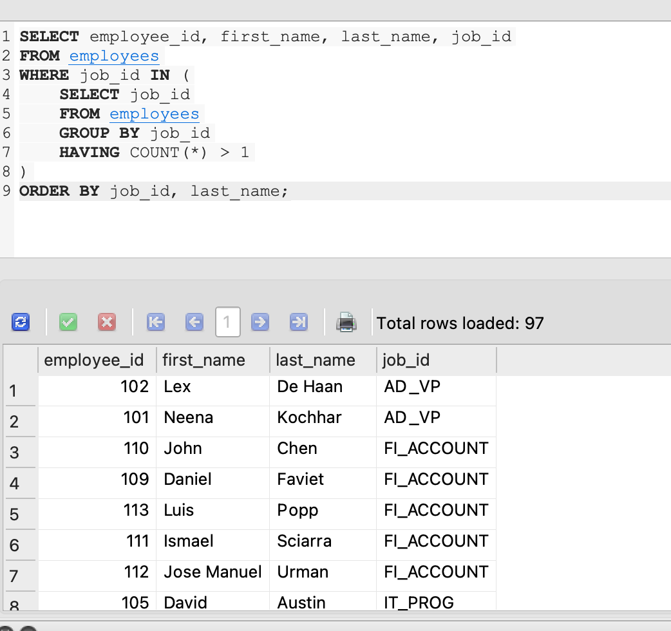

20. Find the manager ID and the salary of the lowest-paid employee for that manager.

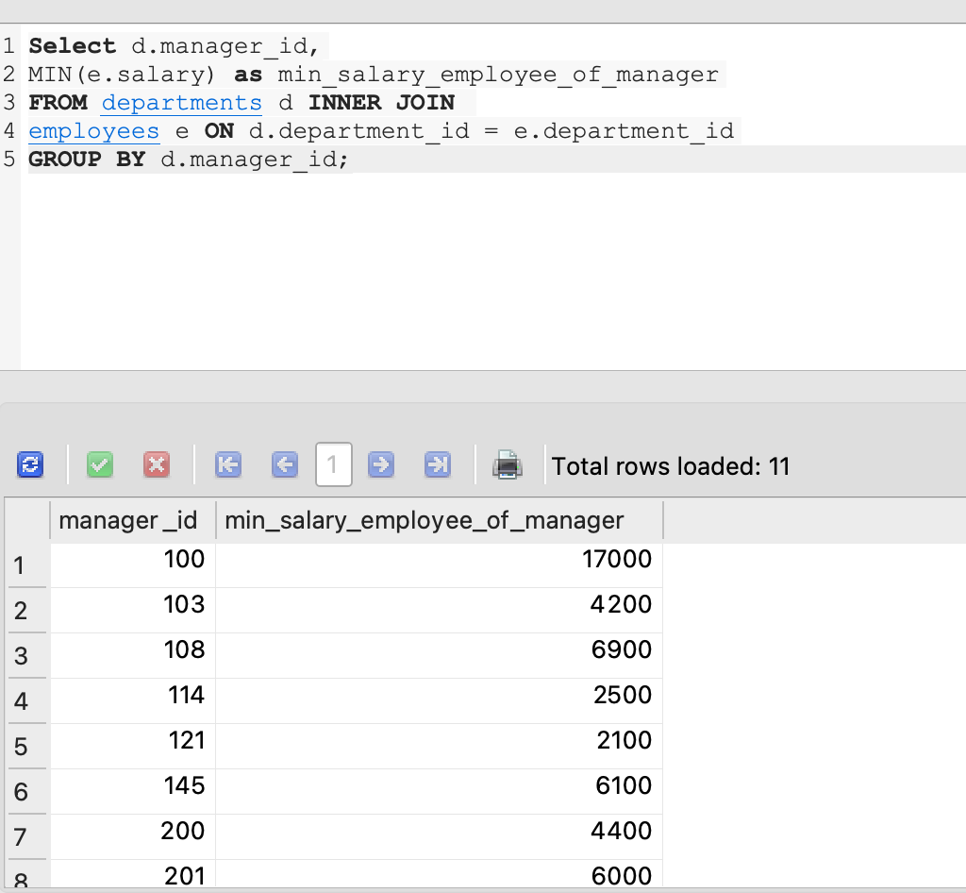

# ASSIGNMENT 4 - ANSWERS

QUESTION 1

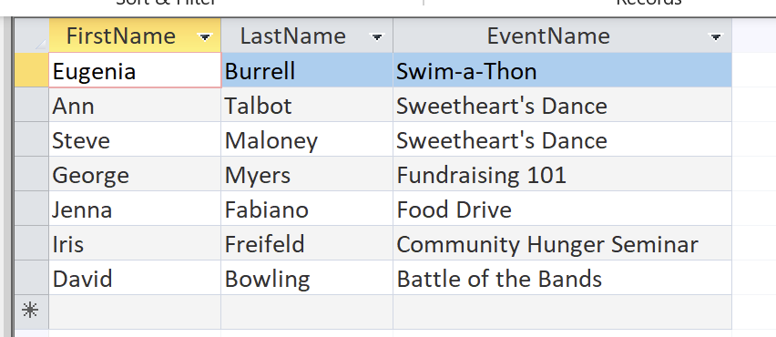



QUESTION 2

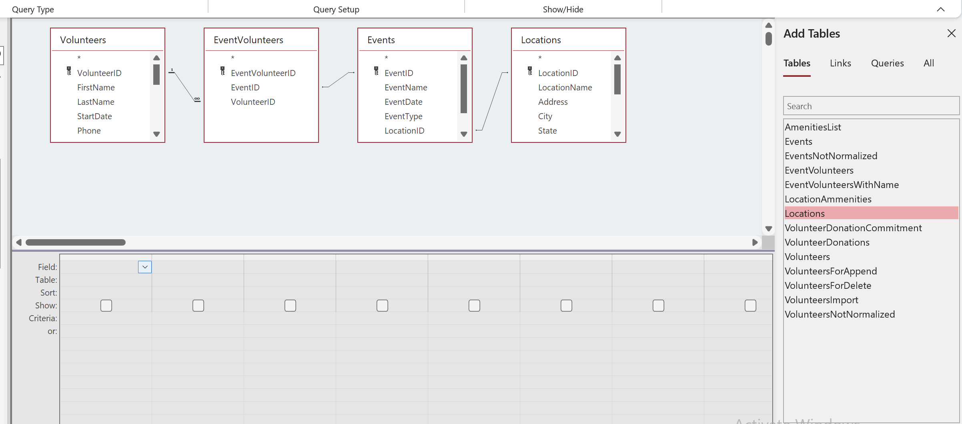

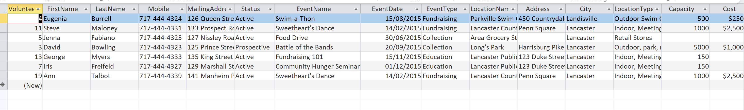

E,

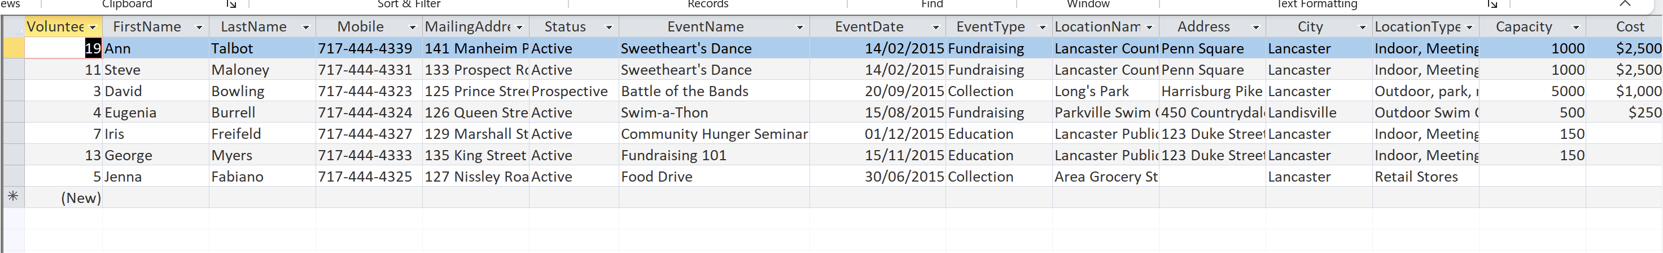



D,F





QUESTION 3

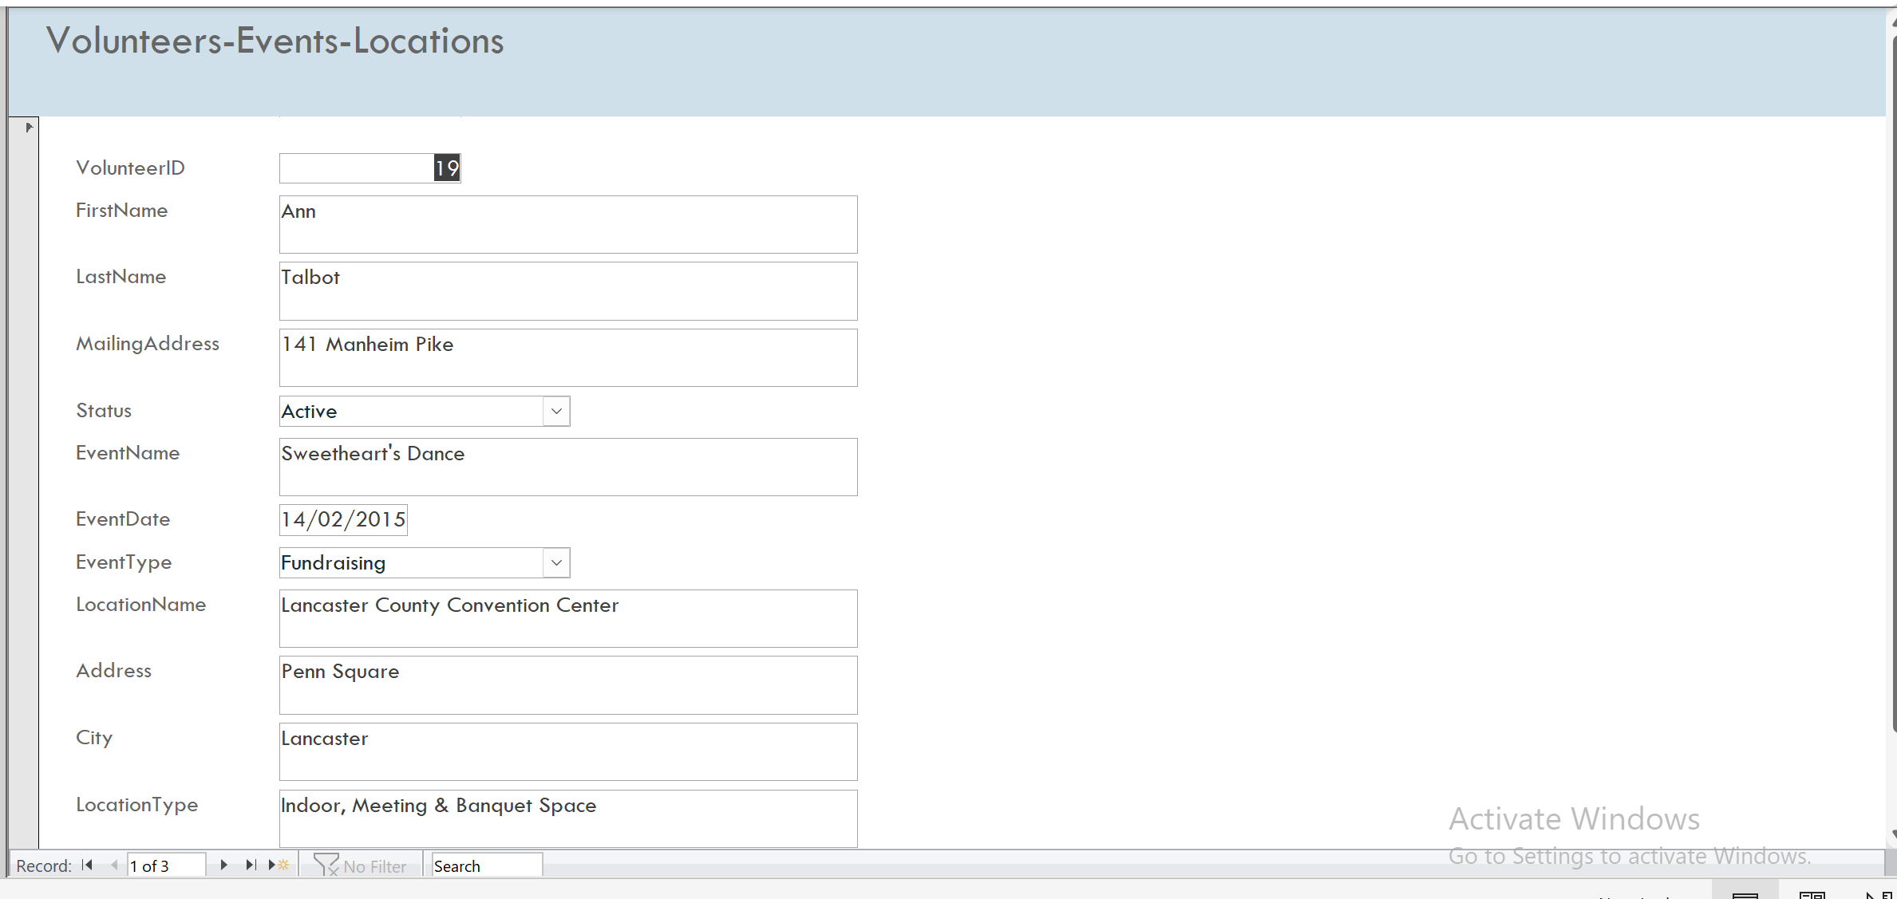

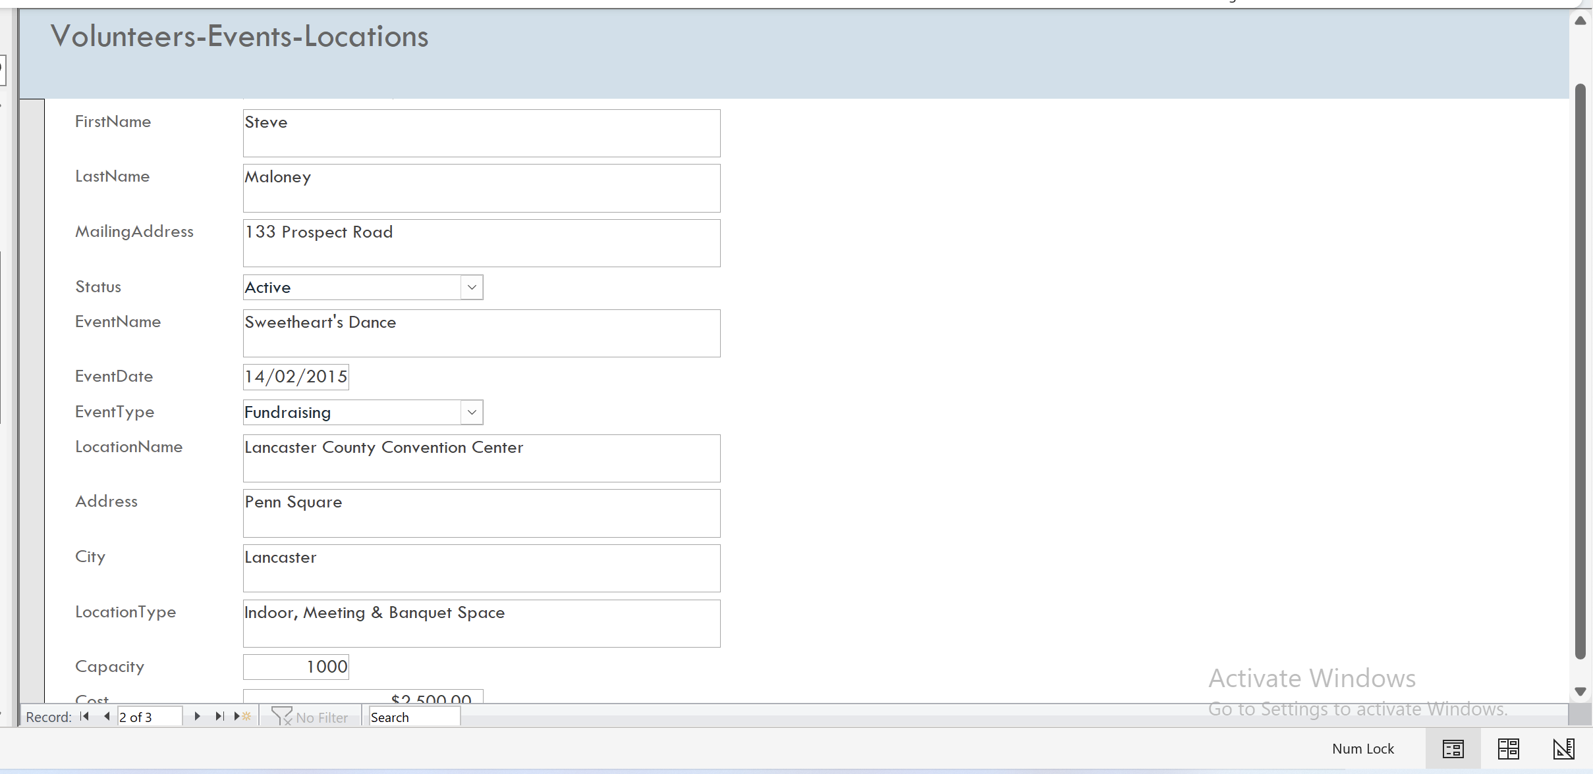

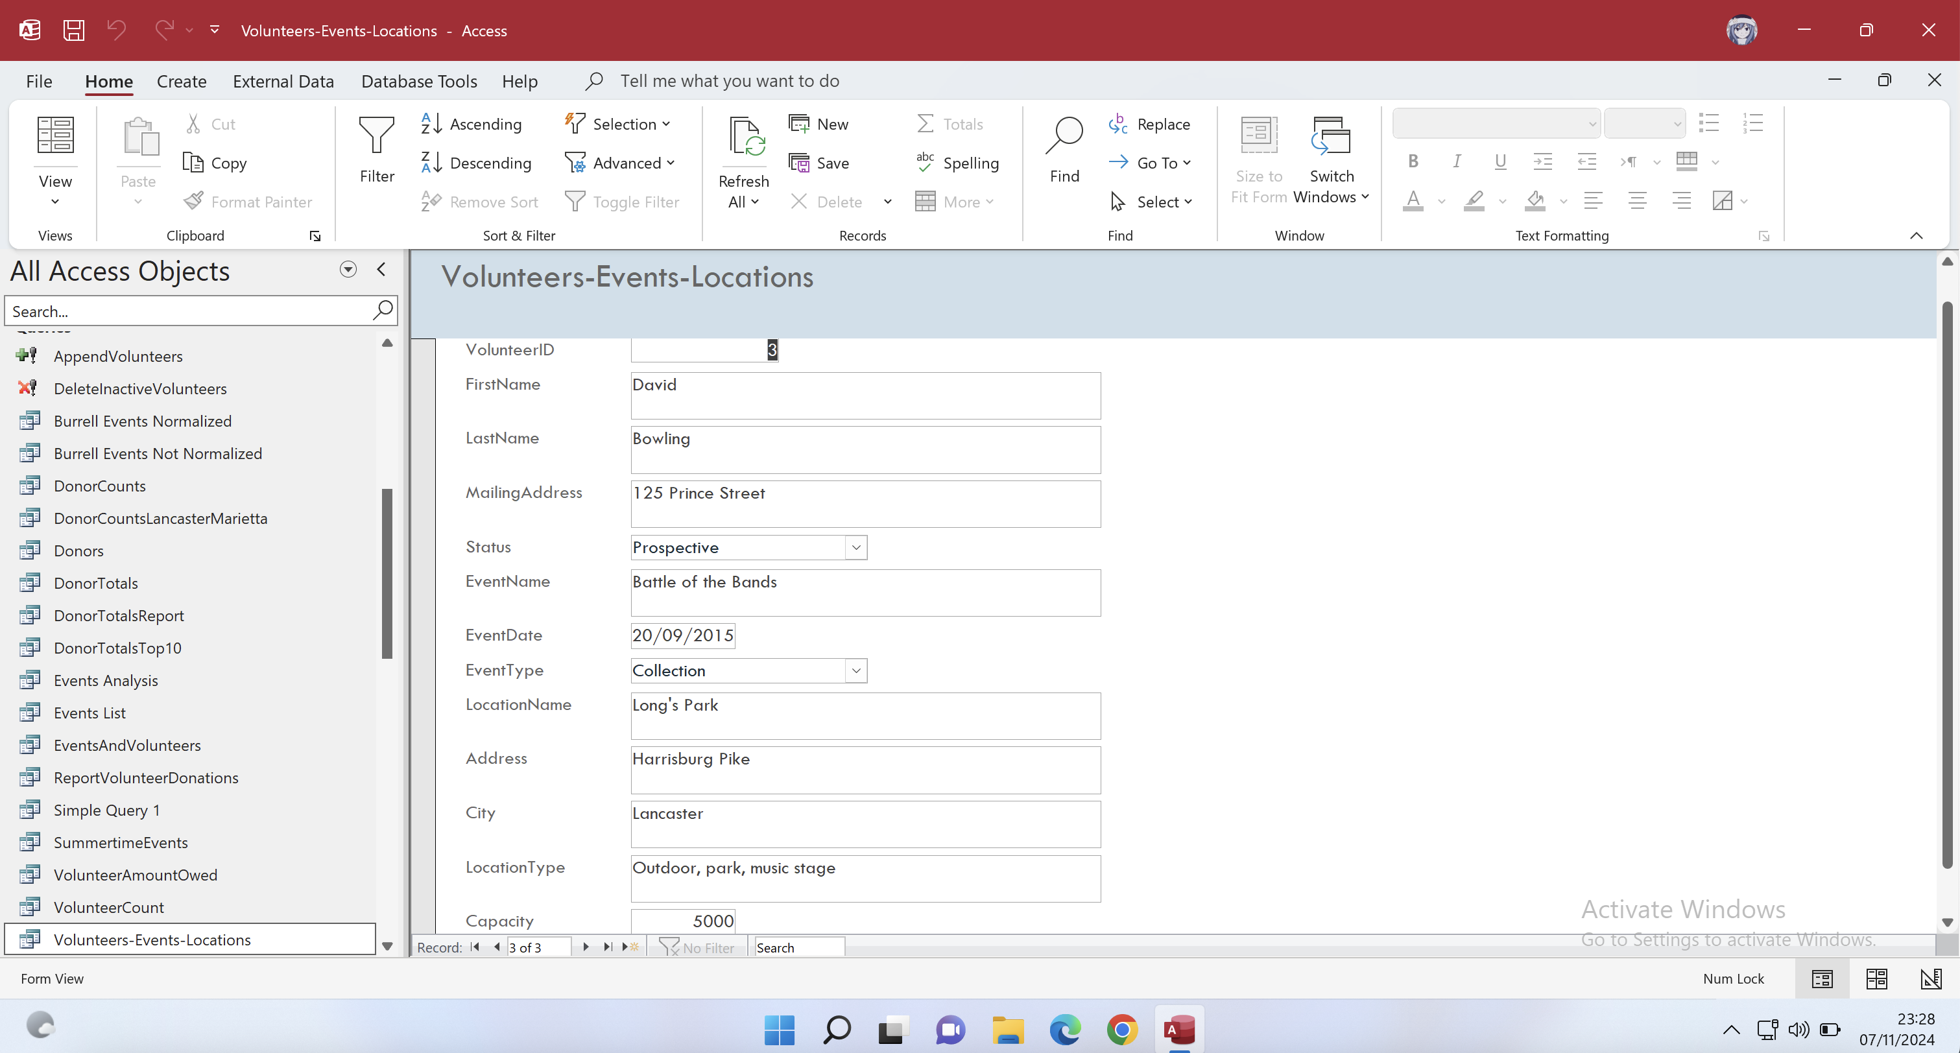

Have 3 records in new form